

Installation and Customization Guide
PowerEditor 5.9

First Issued: February 24, 2014
Revised: February 24, 2014

Notice: This document includes confidential and proprietary data that is within the scope of non-disclosure agreements between MindBox and its alliances. The document shall not be duplicated, used or disclosed - in whole or in part - for any purpose other than that specified within the scope of such an agreement. Acceptance of this document presumes adherence to the above conditions.

The PowerEditor documentation suite includes the following materials:

PowerEditor Business Analysts Guide
PowerEditor Custom Reports Guide
PowerEditor Installation and Customization Guide
PowerEditor Reference Manual
PowerEditor Release Notes
PowerEditor Rule Writers Toolkit

Release Notes for earlier versions are also provided in the release package. For technical assistance with upgrading or any other PowerEditor-related issue please contact MindBox Technical Support at 1-888-650-6463, or Support@mindbox.com.

Table of Contents

1. Introduction 7
2. PowerEditor Server System Requirements 8
2.1 OS Requirements 8
Windows 8
VMware® 8
2.2 Java Configuration Requirements 8
2.3 Web Application Server Requirements 9
Memory Requirements 9
Servlet Start-Up 9
Servlet Port Number 9
Servlet Container Log Files 9
Sample Servlet Containers 9
Database Requirements for PE Server 10
2.4 Miscellaneous Configuration Requirements 10
2.4.1 LDAP Requirements 10
2.4.2 Crystal Reporting Requirements 10
3. PowerEditor Server Installation 11
3.1 Server Installation - InstallShield Wizard 11
3.2 Server Installation – Manual Installation 11
3.2.1 Server Installation Step 1: Expand PowerEditor WAR File 11
3.2.2 Server Installation Step 2: Configure Database and Password. 12
3.2.3 Server Installation Step 3: Modify Server Configuration Options 12
3.3 Server Installation – Database Configuration 13
3.3.1 Microsoft Access DB Configuration 13
Microsoft Access Database Configuration 13
ODBC Configuration for Microsoft Access 13
3.3.2 MySQL DB Configuration 14
3.3.3 Oracle DB Configuration 15
3.3.4 SQL Server DB Configuration 15
3.3.5 Sybase DB Configuration 16
3.3.6 Table Indexing 17
3.4 Password Encryption 17
3.5 Server Configuration Validation and Troubleshooting 18
3.5.1 Trouble-Shooting 19
4. PowerEditor Server Upgrade Procedures 21
5. PowerEditor Client Installation 22
5.1 PE Client System Requirements 22
5.2 PE Client Installation Instructions 22
5.2.1 Basic Instructions 22
5.2.2 Client Installation Refinements 23
5.2.3 PE Client Installation Trouble-Shooting Suggestions 24
5.2.3.1 Connection Failure 24
5.2.3.2 Login Failure 27
5.2.3.3 Where are my Tabs? 29
6. PowerEditor Web Services API 30
6.1 Test with Sample Client 30
6.1.1 Call Ping with Sample Client 31
6.1.2 Call Other Functions with Sample Client 31
6.2 Build Test Client 31
6.2.1 Building Java Client 31
6.2.2 Building C# Client 32
6.2.3 Building a Different Client 32
6.3 Build Real Client 32
6.4 Client API Security Levels 33
6.4.1 Unencrypted Credentials 33
6.4.2 Encrypted Credentials 33
6.4.3 HTTPS 33
6.5 Client API Technical Specifications 33
6.5.1 Requiring Encrypted Credentials 33
6.5.2 Web Service Methods 34
6.5.2.1 Deploy API 34
6.5.2.2 Importing Entities API 36
6.5.2.3 Export API 37
6.5.2.4 Ping 38
7. PowerEditor Customization Guide 39
7.1 High-Level Tab Configuration 39
7.2 Entity Configuration 41
7.2.1 Entity Configuration Overview 41
7.2.2 Entity Definition 42
CategoryType 43
EntityType 43
EntityProperty 44
7.3 User Interface Customization 46
7.3.1 User Interface: Entity Display 46
7.3.2 User Interface: Usage Type List 47
7.3.3 User Interface: Guideline Management 47
7.3.3.1 Guideline Tabs 47
7.3.3.2 Sorting Enumerated Values 48
7.3.3.3 Fit Grids to Screen 49
7.3.4 User Interface: Miscellaneous Options 50
7.3.5 User Interface: Policy Management 51
7.3.5.1 Enforcing Sequential Activation Dates 51
7.4 Rule Generation Options 51
7.4.1 LHS Options 51
7.4.1.1 LHS Request Pattern 51
7.4.1.2 LHS Control Pattern 53
7.4.1.3 LHS Static Pattern 55
7.4.1.4 LHS Empty Pattern Variable Option 55
7.4.1.5 LHS - Setting Deploy Value For IS-Empty Operator 55
7.4.2 RHS Options 55
7.4.2.1 RHS Multi-Enum As Sequence Option 55
7.4.3 Message Generation Options 55
7.4.4 Parameter Generation Options 56
7.5 Server Customization 56
7.5.1 Knowledge Base 56
7.5.2 Audit Trail 57
7.5.3 Database Connection 57
7.5.4 Deployment 57
7.5.4.1 Deployment Directories 57
7.5.4.2 Data Available to Post Deployment Script 58
7.5.5 Log Files 58
7.5.6 Session Control 59
Maximum Concurrent Sessions 59
Session Time-out 59
7.6 Enumeration Source Configuration 59
7.6.1 Enumeration Source Declaration 60
7.6.2 Format of Enumeration XML Files 60
7.6.3 Sample Enumeration XML File 61
7.6.4 Example of Use 61
7.7 LDAP, Authentication, and Authorization 62
7.7.1 Overview and Definitions 62
PE Authentication 63
LDAP Authentication 63
Custom Authentication 64
7.7.2 PE Authentication Configuration Overview 64
PE Authentication and Authorization 64
LDAP Authentication and Authorization 64
Custom Authentication / PE Authorization 64
7.7.3 LDAP Overview 65
PowerEditor LDAP Configuration Options 65
7.8 Password Policies 67
7.8.1 Overview 67
7.8.2 Example Password Policies 68
7.8.3 Lockout Behavior 68
7.8.4 Password Policy Configuration File Specifications 69
8. Configuration File Reference 71
8.1 Summary of Feature Configuration Parameters 71
8.2 Summary of Entity Configuration Parameters 72
8.3 Summary of UI Configuration Parameters 73
8.4 Summary of Rule Generation Parameters 74
8.5 Summary of Server Parameters 76
9. Appendix I: LDAP Server - Sample Installation 79
9.1 Obtain Configuration Files 79
9.2 Install and Configure LDAP Server Application (OpenLDAP) 79
9.3 Install LDAP Client Application (JXplorer) 81
9.4 Use Client Application to Configure PowerEditor LDAP Settings 82
9.5 Restarting JXplorer 86
9.6 Debugging Open LDAP 86

Introduction
The following document provides technical specifications for installing and configuring the MindBox PowerEditor. This document should be used in conjunction with the PowerEditor Release Notes that are specific to the release you are using. For an overview of the PowerEditor from a user’s perspective, please refer to the PowerEditor User’s Guide, which is a document distributed with each software release.

This document provides the following information:
- System Requirements
- General Installation Instructions
- Configuration Instructions

For technical support, contact MindBox Technical Support at Support@mindbox.com, or 1-888-650-6463.

Other documents distributed with the PowerEditor include:
PowerEditor Business Analysts Guide | Intended for Business Analysts who are using the PowerEditor to develop business rules.
PowerEditor Custom Reports Guide | Describes the report-writing API provided by the PowerEditor. It provides examples for writing Crystal Reports that contain PowerEditor data.
PowerEditor Reference Manual | Provides an overview of PowerEditor and describes various features, considered as general users’ guide.
PowerEditor Rule Writers Toolkit | Intended for technically savvy users, provides description of functionality that are not covered in the Business Analysts Guide or the Reference Manual.

PowerEditor Server System Requirements
The PowerEditor (PE) is a web-based client/server application. This section describes the system requirements for the machine that hosts the PowerEditor server application. See Section 5 PowerEditor Client Installation for system requirements for the PowerEditor client.

The PowerEditor server is distributed as a Java web application, and therefore can be run on any operating system that runs Java 1.6. The machine that runs the PowerEditor server machine must be configured with the following components:
- Java SDK with JCE unlimited strength jurisdiction policy
- A Java application server
- Connection to relational database that will contain PowerEditor data
Specific requirements for these components are described in the sections to follow.

OS Requirements
The PowerEditor server software can be run on any operating system (OS) that runs Java 1.6. Note that if you are using Java 1.5, make sure to get the latest patches. The earliest versions had significant performance issues.

Windows
The PE server software can run on any Windows NT-based OS. This includes, but is not limited to the following Windows operating systems:
- Windows 2000
- Windows XP
- Windows 2003 Server

PowerEditor can also be run in a Linux or Unix environment.

Development server machines should minimally be configured with the following:
- 512 MB Ram
- 2 GB Disk Space

Production server machines should be minimally configured with the following:
- 1 GB Ram
- 10 GB Disk Space

VMware®
The PE server has also been tested with VMware®. The VMware memory requirements are at least 512MB for development and testing servers, and 1GB for production servers.

Note: Although the PowerEditor server and client software can be run on a variety of operating systems, this document contains examples from Windows XP.

Java Configuration Requirements
The PowerEditor server machine must be configured with the Sun JDK 1.6 (Java Development Kit). The JDK is sometimes referred to as the J2SE SDK (Java 2 Standard Edition, Software Development Kit). Note: Do not confuse the JDK with the JRE. The JRE (Java Runtime Environment) is not sufficient for the PowerEditor server machine, although it is sufficient for the PowerEditor client machines.

The Sun JDK is available at http://java.sun.com/j2se/downloads.html. Again, be sure to download the JDK and not the JRE. Note that the download file is quite large. Once downloaded, execute the file and follow the installation instructions on the screen.

IMPORTANT Java Compatibility Note
PowerEditor versions 5.5 and above requires Java version 1.6.

Web Application Server Requirements
The PowerEditor server machine must be configured with a Java servlet container, which a mechanism for extending the functionality of a Web server for Java servlets. This can also be referred to as a servlet engine, a JVM process, or more loosely as a web application server. Examples of Java servlet containers include Apache Tomcat or Resin. You can find out more about Java servlet containers via:
http://java.sun.com/products/servlet/overview.html

The Servlet container must be “War” file compliant and must support JSP 1.2.

PowerEditor must be run on a single instance of your servlet container. Running a cluster of servlet container instances that each serve the PowerEditor will lead to cache synchronization issues, which can lead to database corruption.

Memory Requirements
The servlet engine has the following memory requirements for running the PE Server:
- Development machines should be allocated at least 256MB of memory
- Production machines should be allocated at least 512MB of memory
The procedure for configuring memory allocation is dependent upon the vendor-specific servlet container – see vendor documentation for memory configuration options.

Servlet Start-Up
On production machines running in Windows, it is recommended that your servlet contain is installed as a Windows Service. In this way, the PowerEditor server will automatically be launched when the server machine is booted. This can be achieved in the Windows Service control panel.

Servlet Port Number
You’ll need to know what port number your servlet container uses for application requests, and make sure that no other applications on your server machine are using that port. For example, Resin uses port 8080 by default, which is configurable in the resin.conf file in the Resin directory. Other servlet containers specify this differently.

Servlet Container Log Files
You’ll need to know where your servlet container stores its log files, so that you can troubleshoot potential configuration issues. This log file is not to be confused with the log files that the PowerEditor creates.

Sample Servlet Containers
The following presents various Java servlet options that have been tested with the PowerEditor.

Tomcat The PowerEditor requires Tomcat 5.0 or above. Tomcat 4.0 can be used in conjunction with JDK 1.6. Tomcat can be downloaded via:
http://jakarta.apache.org/ .

To use the PowerEditor 5.0 and above with Tomcat, you must install JSTL into Tomcat. JSTL can be obtained from the same source as Tomcat. To use JSTL, you must unzip the distribution files and install them into the correct locations within Tomcat. For more information, see:
http://jakarta.apache.org/taglibs/doc/standard-doc/intro.html

Resin The PowerEditor requires Resin EE, Version 2.1 or above. Resin is available at
http://www.caucho.com/download/.

Once the download is unzipped, Resin can be launched by running the following executable:
<resin-dir>/bin/httpd.exe

JBoss JBoss can be downloaded via http://labs.jboss.com/portal/jbossas

WebLogic Information on BEA’s WebLogic server is available via http://www.bea.com.

WebSphere Trial version of IBM’s WebSphere is available at
http://www-128.ibm.com/developerworks/websphere/downloads/

Database Requirements for PE Server
PowerEditor supports the following databases:
- MySQL
- SQL Server
- MS Access
- Oracle
- Sybase

The following lists specific DB versions that the PowerEditor has been tested with. If you wish to use versions other than those listed here, please consult with MindBox technical support.
- MySQL 4.1.10a for Windows
- SQL Server 2000 – the page size should be configured to be 8k rather than default of 2k
- Microsoft Access 2003
- Oracle 9.0.1
- Sybase 12.5.x

Miscellaneous Configuration Requirements

LDAP Requirements
The PowerEditor can optionally be configured for user authentication and authorization using the LDAP API. See Section 7.7 LDAP, Authentication, and Authorization for more details.

PowerEditor supports LDAP v3.

Crystal Reporting Requirements
The PowerEditor provides for generating reports using Crystal Reports. See the PowerEditor Custom Reports Guide for more details.

Crystal Reports XI Release 2 Developer Edition is required for building PowerEditor reports. PowerEditor Version 4.5.0 has been tested with Crystal Reports Version 11.0.0.2002.

PowerEditor Server Installation
The following section assumes that server machine that will be running the PowerEditor server software has been configured as per the system requirements outlined above in Section 2 PowerEditor Server System Requirements. In summary, this section assumes that the following have been installed on the server machine:
- OS configured with correct memory requirements
- Java JDK
- Java Servlet Container (e.g. Resin, Tomcat, etc.)
- Database Software (e.g. Access, SQL Server, etc.)
- Database Connector for your Database Software (e.g. ODBC or JDBC)

This chapter contains 3 major sections:
- Server Installation - InstallShield Wizard
- Server Installation – Manual Installation
- Database Configuration
- Password Encryption
- Installation Validation and Troubleshooting

Server Installation - InstallShield Wizard
Most PowerEditor releases come with an InstallShield wizard for installing the PowerEditor server. This will install the server software, set up an MS Access database with an ODBC connection, and install configuration files with appropriate pathnames.

If you want to use a database other than MS Access, use the installer, then follow database-specific instructions as specified in Section Error: Reference source not found.

To install PowerEditor using automated installer, download InstallShield installation distribution, and run the installation program. Then, follow instructions on screen.

Server Installation – Manual Installation
Although the InstallShield wizard is the best way to install the PowerEditor server on a new machine, sometimes it is necessary to manually install the server. This section contains manual installation instructions.

Manually installing the PowerEditor server is comprised of the following steps:
- Expand PowerEditor WAR File
- Configure an empty PE database, its database connector and its password
- Modify Server Configuration Options

Server Installation Step 1: Expand PowerEditor WAR File
- Obtain the powereditor.war. Clients can get this from http://softdist.mindbox.com. MindBox employees can obtain this from https://mindshare.mindbox.com/FileLib/Public/Editors/ .
- Place the powereditor.war file into the <webapps> directory of your Servlet Engine. For example, C:\resin-ee-2.1.11\webapps.
- Start your Servlet engine, (If it was running, close and restart it). This will expand the powereditor.war file.

Your Servlet engine should expand the WAR file into a proper directory structure under the following directory: <webapps>/powereditor.

Server Installation Step 2: Configure Database and Password.
See Section 3.3 Server Installation – Database Configuration and Section 3.4 Password Encryption.

Server Installation Step 3: Modify Server Configuration Options
PowerEditor uses XML configuration files. They are included in the WAR file. They are found in the <webapps>/powereditor/WEB-INF directory, after successful completion of Section 3.2.1 Server Installation Step 1: Expand PowerEditor WAR File. The following table lists the configuration files of the PowerEditor.

Filename | Description | Default Location
MortgageDomain.xml | Declares what classes and attributes are available to PE. | <webapps>/powereditor/WEB-INF
PowerEditorConfiguration.xml | Configuration file for PE UI and server. | <webapps>/powereditor/WEB-INF
web.xml | Application configuration file for PE server. | <webapps>/powereditor/WEB-INF
Figure 3-1: PowerEditor Configuration Files
- Customize the MortgageDomain.xml and save a copy in a directory outside of <webapps> directory, for example, c:\powereditor\config. You may want to use the MindBox DomainEditor to customize them or create them from scratch. You can rename this file.
- If you plan to use parameters, create a parameter template file. See PE Parameter Editor Developer Guide for more details.
- Customize the PowerEditorConfiguration.xml file. For detailed discussion of each configuration parameter, see Section 6: PowerEditor Customization Guide.
  - Modify the text of the <Deployment><BaseDir> tag so that it points to the directory where deployed rules will be stored. Make sure this directory exists.
  - <Log> section defines fully qualified path names to PE log files. Make sure they point to a file in a directory that already exists.
  - Modify <Server><KnowledgeBase><DomainFile> to point to the MortgageDomain.xml file you saved in Step 1 above.
  - If you have a parameter template definition file, modify reference to <Server><KnowlegeBase><TemplateFile> to point to the parameter template file you created in Step 2.
- Customize the web.xml file. The web.xml file is a configuration file for application deployed in a Servlet Engine. Note that web.xml file must reside in the <webapps>/powereditor/WEB-INF directory.
  - Edit the web.xml file and find lines that read:
<init-param>
<param-name>ConfigurationFile</param-name>
<param-value>c:/resin-ee-2.1.11/webapps/powereditor/WEB-INF/PowerEditorConfiguration.xml</param-value>
</init-param>

  - Replace the text of <param-value> tag with the full path of your PowerEditorConfiguration.xml.

- Restart the Servlet Container.
- Validate configuration as discussed in Section 3.5 Server Configuration Validation and Troubleshooting.

Server Installation – Database Configuration
If you used the InstallShield wizard, and are using MS Access, you can skip this section. Otherwise, read on. This portion of the document describes database configuration steps for Access, My SQL, Oracle, SQL Server, and Sybase. Instructions in this section assumes you have extracted files from powereditor.war, and the extracted files are located in <webapps>/powereditor directory.

As an overview, it is good to PowerEditorConfiguration.xml provides the following database options in the <Server><Database>. See the instructions for your particular database to see how to configure these options.

Parameter | Value
Provider | Do not change. Should be com.mindbox.pe.server.db.DefaultPEDBCProvider
Driver | - For ODBC Driver, use “sun.jdbc.odbc.JdbcOdbcDriver”.  - For JDBC Driver, enter the name of the Driver class.
Connection | - For ODBC Driver, enter jdbc:odbc:<DSN-Name>, where <DSN-Name> is the name of the System DSN you setup in Section 2.4.2.1.  - For JDBC Driver, enter the JDBC connection string for your DB.
User | Enter the login name for accessing the DB.
Password | Enter the encrypted password for the DB user. See Section 3.4 Password Encryption.
MaxConnection | Enter the maximum number of concurrent connections allowed. Value greater or equal to ten is recommended.
ValidationQuery | This is an optional entry. Enter a valid select count query that should be run before using each DB connection to validate the connection, for example, select count(*) from MB_PRIVILEGE
Figure 3-2 Database Configuration Options

Microsoft Access DB Configuration
This section contains instructions for configuring a MS Access database with and ODBC connector. The instructions assume that MS Access is already installed and running. The instructions also assume that the PowerEditor WAR file has been expanded on the server machine.

Microsoft Access Database Configuration
The powereditor.war file contains a blank MS Access database at <webapps>/powereditor/WEB-INF/database/MB-PEDB-EMPTY.mdb. You may use this for your installation. If you are using MS Access, simply copy this file to a directory outside of the <webapps> directory of your Servlet engine. The MB-PEDB-EMPTY.mdb is also included in the PowerEditor distribution file under database folder.

Note that the empty PE database contains only one user. Use demo/demo as the user id/password to sign in.

ODBC Configuration for Microsoft Access
In summary, the following steps create a new System ODBC DSN for the database setup in the above section.
- Open Data Sources control panel, usually available under Control Panel / Administrative Tools.

- Go to System DSN Tab, and click Add under the System DSN tab.
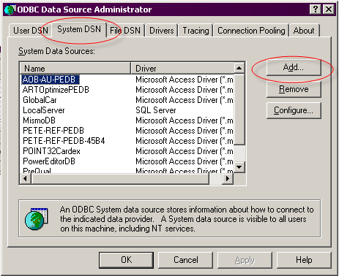
Figure 3-3 Create New ODBC Driver

- Select the appropriate Driver type. For MS Access, choose “Microsoft Access Driver (*.mdb)” and for MS SQL Server, “SQL Server”.
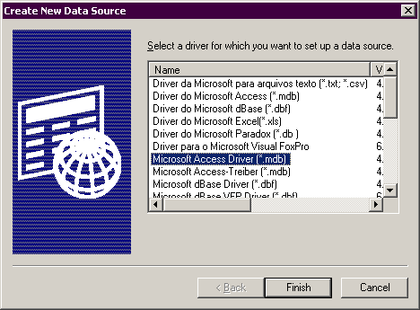
Figure 3-4 Create ODBC Driver for Microsoft Access

- Follow the instructions on the screen to complete the ODBC setup.

Note that the default name to use for the DSN is “PowerEditorDB.” If you want to specify a data source name other than “PowerEditorDB,” please make a note of it as you will need it when configuring the PowerEditor later.

MySQL DB Configuration
This section contains instructions for configuring a MySQL database and JDBC connector. The instructions assume that MySQL is already installed and running. The instructions also assume that the PowerEditor WAR file has been expanded on the server machine.

- Determine the server name and port used by MySQL. By default MySQL runs on port 3306.
- Create a new database for PowerEditor and a user who has create/select/insert/update access to the database.
- Run all SQL statements in the <webapps>/powereditor/WEB-INF/database/powereditor-db-create-tables-MySQL.sql file. This will create the tables required by PE.
- Run all SQL statements in the <webapps>/powereditor/WEB-INF/database/powereditor-db-init-data-generic.sql file. This will populate the database with the minimum data required to run PE. You will be able to modify some of data created using PE GUI later.
- Modify PowerEditorConfigruation.xml such that the <Server><Database> section reads as shown in the figure below. In this figure, in the <Connection> tag, host:port is the server name and port number used by MySQL, and database-name is the name of the database you created in Step 2. Be sure to update the <User> and <Password> tags with the correct value. See Section 3.4 Password Encryption.
- Restart PowerEditor.
<Database>
<Provider>com.mindbox.pe.server.db.DefaultPEDBCProvider</Provider>
<MaxConnection>20</MaxConnection>

<!-- MySQL Settings -->
<Driver>com.mysql.jdbc.Driver</Driver>
<Connection>jdbc:mysql://host:port/database-name</Connection>
<User>powereditor</User>
<Password>9Ak9tSbRBG6GdVTvrpG7mQ==</Password>
</Database>
Figure 3-5: PE Configuration for MySQL

Oracle DB Configuration
This section contains instructions for configuring an Oracle database and JDBC connector. The instructions assume that Oracle is already installed and running. The instructions also assume that the PowerEditor WAR file has been expanded on the server machine.

- Determine the server and port Oracle is running on.
- Obtain the SID of the database to be used with PowerEditor.
- Run all SQL statements in the <webapps>/powereditor/WEB-INF/database/powereditor-db-create-tables-Oracle.sql file. This will create the tables required by PE.
- Run all SQL statements in the <webapps>/powereditor/WEB-INF/database/powereditor-db-init-data-generic.sql file. This will populate the database with the minimum data required to run PE. You will be able to modify some of data created using PE GUI later.
- Modify PowerEditorConfigruation.xml such that the <Server><Database> section reads as shown in the figure below. In this figure, in the <Connection> tag, host:port is the server name and port number used by Oracle, and SID is the SID of the PowerEditor database. Be sure to update the <User> and <Password> tags with the correct value. See Section 3.4 Password Encryption.
- Download \\mbhqweb\softdist-public\editros\jdbc-driver\oracle-jdbc14.zip file.
- Extract files from the zip and place them into <webapps>/powereditor/WEB-INF/lib directory.
- Restart PowerEditor.
<Database>
<Provider>com.mindbox.pe.server.db.DefaultPEDBCProvider</Provider>
<MaxConnection>20</MaxConnection>

<!-- Oracle Settings -->
<Driver>oracle.jdbc.driver.OracleDriver</Driver>
<Connection>jdbc:oracle:thin:@host:port:SID</Connection>
<User>mindbox</User>
<Password>9Ak9tSbRBG6GdVTvrpG7mQ==</Password>
</Database>
Figure 3-6: PE Configuration for Oracle

SQL Server DB Configuration
This section contains instructions for configuring a SQL Server database and JDBC connector.

When installing SQL Server make sure it is configured as follows:
- If using SQL server in a private development environment, configure SQL Server for SQL Server and Windows authentication. This will make it easier for PowerEditor to log into the SQL Server.
- Change the SQL Server page size from 2k to 8k. This will allow more data per cell, which is needed for storing template definitions.

Once SQL Server is running, and the PowerEditor war file is expanded, perform the following instructions:
- Determine the server and port SQL Server is running on. By default SQL Server runs on port 1433.
- In SQL Server, create or identify a username that the PowerEditor will use to access the database.
- Log into the SQL server with the same username that the PowerEditor will use for logging in. Logging in with the same username will make sure that table ownership is properly preserved.
- Create a new database to be used with PowerEditor. Make sure that the user has the following permissions on all tables in the database: select, delete, and execute.
- Run all SQL statements in the <webapps>/powereditor/WEB-INF/database/powereditor-db-create-tables-SQLServer.sql file. This will create tables required to run PE.
- Run all SQL statements in the <webapps>/powereditor/WEB-INF/database/powereditor-db-init-data-generic.sql file. This will populate the database with the minimum data required to run PE. You will be able to modify some of data created using PE GUI later.
- Modify PowerEditorConfigruation.xml such that the <Server><Database> section reads as shown in the figure below. In this figure, in the <Connection> tag, host:port is the server and port SQL Server is running on, and database-name is the name of the PowerEditor database created in Step 2. Be sure to update <User> and <Password> with the correct value. See Section 3.4 Password Encryption.
- Restart the Servlet Container.
<Database>
<Provider>com.mindbox.pe.server.db.DefaultPEDBCProvider</Provider>
<MaxConnection>20</MaxConnection>

<!-- SQL Server Settings -->
<Driver>com.microsoft.jdbc.sqlserver.SQLServerDriver</Driver>
<Connection>jdbc:microsoft:sqlserver://host:port;SelectMethod=Cursor;DatabaseName=database-name</Connection>
<User>servlet</User>
<Password>9Ak9tSbRBG6GdVTvrpG7mQ==</Password>
</Database>
Figure 3-7: PE Configuration for SQL Server

Sybase DB Configuration
This section is used if you intend to use a Sybase database.
Known Issue: PowerEditor 4.5 has not successfully been tested with Sybase. If you intend to use Sybase, please contact MindBox Technical Support.
- Determine the server and port Sybase DB is running on.
- Create a Sybase instance with 8KB page size. If you are using an existing instance, make sure the page size is greater than or equal to 8KB.
- Create a new database to be used with PowerEditor with the minimum size of 10MB. If you are plan to import guidelines from a previous version of PowerEditor, increase the size accordingly.
- Run all SQL statements in the <webapps>/powereditor/WEB-INF/database/powereditor-db-create-tables-Sybase.sql file. This will create tables required to run PE.
- Run all SQL statements in the <webapps>/powereditor/WEB-INF/database/powereditor-db-init-data-generic.sql file. This will populate the database with the minimum data required to run PE. You will be able to modify some of data created using PE GUI later.
- Modify PowerEditorConfigruation.xml such that the <Server><Database> section reads as shown in the figure below. In this figure, in the <Connection> tag, host:port is the server and port Sybase DB is running on, and database-name is the name of the PowerEditor database created in Step 2. Be sure to update <User> and <Password> with the correct value. See Section 3.4 Password Encryption.
- Download \\mbhqweb\softdist-public\editors\jdbc-driver\Sybase-jconn3.zip file.
- Extract files from the zip and place them into <webapps>/powereditor/WEB-INF/lib directory.
- Locate powereditor-wrapper.jar file from the distribution zip file and place it into the <webapps>/powereditor/WEB-INF/lib directory. Note: this file is not included in the powereditor.war file, but is part of the ZIP file that PowerEditor is distributed with.
- Restart the Servlet Container.
<Database>
<Provider>com.mindbox.pe.server.db.DefaultPEDBCProvider</Provider>
<MaxConnection>20</MaxConnection>

<!-- SQL Server Settings -->
<Driver>com.mindbox.pe.wrapper.sybase.PESybaseDriver</Driver>
<Connection>jdbc:pesybase:Tds:host:port/database-name</Connection>
<User>servlet</User>
<Password>9Ak9tSbRBG6GdVTvrpG7mQ==</Password>
</Database>
Figure 3-8: PE Configuration for Sybase

Table Indexing
If you are having performance issues, you'll probably want to profile your PowerEditor database. Here are some suggestions for DB indices based on previous profile runs:

MB_ENTITY_CATEGORY_LINK: entity_id and entity_type (compound index)
MB_ENTITY_CATEGORY_PARENT: category_id and category_type (compound index)
MB_ENTITY_GRID_CONTEXT: grid_id
MB_GRID_CELL_VALUE: grid_id
MB_TEMPLATE_COLUMN: template_id
MB_TEMPLATE_COLUMN_ATTR_ITEM: template_id
MB_TEMPLATE_COLUMN_ENUM: template_id
MB_TEMPLATE_DEPLOY_RULE: template_id
MB_TEMPLATE_DEPLOY_RULE: template_id and column_no (primary key)
MB_TEMPLATE_MESSAGE: template_id
MB_TEMPLATE_MESSAGE: template_id and column_no (compound index)
MB_TEMPLATE_MESSAGE_FRAGMENT: template_id

Password Encryption
Starting PowerEditor v4.5, the PowerEditor database password and, optionally the LDAP server password, must be encrypted and entered into the PE configuration file before the PE server will start. A password encryption tool is included for completing this task. (This will prevent users with file system access from collecting these passwords. In earlier releases passwords were entered as “clear text” which required significant effort by a System Administrator to secure the configuration file.)

To retrieve and launch the tool:
- Navigate to where PowerEditor tools are installed (typically, c:\MindBox\PowerEditor\tools).
- Double-click on the powereditor-pwd-encrypt-tool.jar file or use the shell command:
java -jar powereditor-pwd-encrypt-tool.jar

To use the tool:
- Enter your password into the Password field and click the Encrypt button.
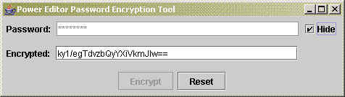
Figure 3-9 Password Encryption Tool

- Copy the encrypted password into your PowerEditorConfiguration.xml file.
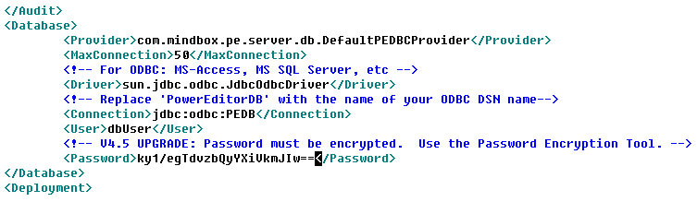
Click the Reset button to clear the fields if you make an error or have other passwords to encrypt.
If passwords aren’t encrypted the PE server instance will fail to start. (If this happens check the server logs or run http://<server>:<port>/powereditor/validate_config.jsp to find out why.) If it’s an encryption issue you’ll see a message like this:
Failed to initialize PE Configuration from c:/mindbox/powereditor/config/PowerEditorConfiguration.xml:
Error decrypting password. Use the PowerEditorPasswordTool to encrypt passwords stored in config files.

Server Configuration Validation and Troubleshooting
So, PowerEditor configuration can be complex. Luckily, there is a tool to help validate and troubleshoot your configuration. The Validate Config tool is accessed by browsing to:
http://<server>:<port>/powereditor/validate_config.jsp

This page validates server configuration. If it finds an error, it will be displayed on the screen. If successful, it will displays configuration details.

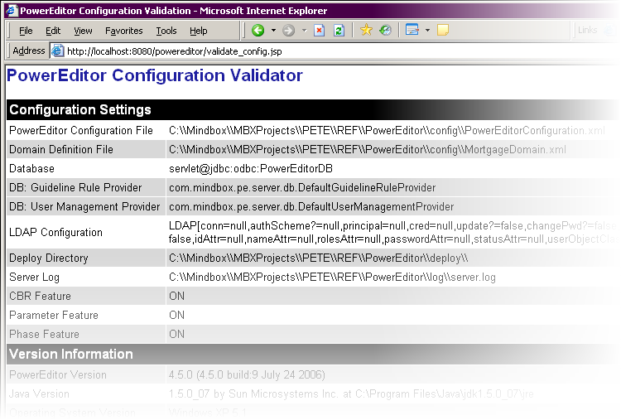
Figure 3-10 Successful Configuration Validation

Invalid configurations can manifest in different ways, often in generating an exception. Although an exception looks scary, the first line will often contain useful information. The following is an example of an invalid configuration.
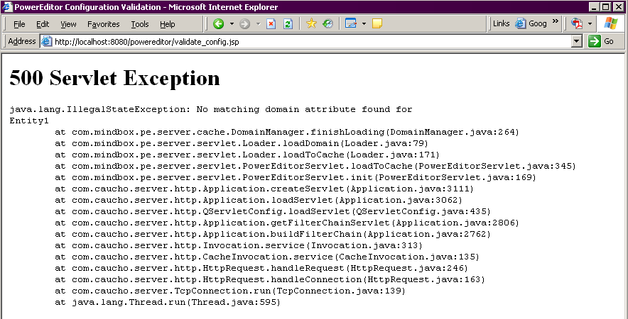
Figure 3-11 Example of Invalid Configuration

Trouble-Shooting
If the config validation results in a browser page not found error, it means that the PowerEditor servlet could not be found. In this case, verify the following:
- Verify the servlet application started without any errors. You can do this by looking at the servlet’s log file. Each servlet vendor has separate locations for their proprietary log file.
- Verify that the servlet is listening to the port you specified. Again, each servlet vendor has separate locations specifying the port number.
- Verify that the host is accessible. This can be achieved by opening a DOS window, and typing:
ping <host>
- Look at the log file for your servlet container (e.g. Resin, Tomcat log files). Note that the PowerEditor log files will not be useful, since the PowerEditor was not reached.

If the browser shows a servlet exception, the PowerEditor was reached, but there was a configuration issue.
- Look at the error on the screen to see if that helps narrow down the configuration error.
- Look at the PowerEditor log files on the PowerEditor server. See Section 7.5.5 Log Files for a description of the log files
- Look at the Java console for client-side errors. See Figure 5-20 Checking Java Console for Client Configuration Error.

PowerEditor Server Upgrade Procedures
Each version of PowerEditor comes with Release Notes that describes specific upgrade instructions. This section describes generic instructions for installing new versions of the PowerEditor over an old version.

- Backup Old Configuration:
  - Export all of your data from your existing configuration. Even for minor upgrades, this is a good process to follow. To do this, use the Admin: Export Data tab. Make sure all the checkboxes are checked (use the Select All button).
  - Backup the PowerEditor database and all configuration files, including the domain definition (MortgageDomain.xml), template definition (TemplateDefinition-Parameter.xml), web.xml, and PowerEditorConfiguration.xml files.
- Backup old PE Server Software version:
  - Shut down the PowerEditor server.
  - Move your existing server files. Find your existing installation of the PowerEditor under the <webapps> directory of your Servlet engine. For example, if you are using resin, you might find the powereditor directory in the following location: C:\resin-ee-3.0.20\webapps\powereditor. Move or rename the powereditor directory, lest it gets overwritten in the subsequent steps. For the purpose of this document, this renamed directory will be referred to as the old powereditor directory.
- Install new server software version
  - Obtain the powereditor.war file from the \\MBHQWEB\Editors network folder or from http://softdist.mindbox.com.
  - Place the powereditor.war file into the <webapps> directory of your Servlet Engine. For example, C:\resin-ee-3.0.19\webapps.
  - Start your Servlet engine, (If it was running, close and restart it). Your Servlet engine should expand the WAR file into a proper directory structure under the “<webapps>/powereditor” directory.
  - Close down your servlet engine.
- Update configuration files:
  - Move your WAR file out of the <webapps> directory, ensuring that it will not re-expand over some of your customized files.
  - Customize the web.xml file. The web.xml file is a configuration file for application deployed in a Servlet Engine. Note that web.xml file must reside in the <webapps>/powereditor/WEB-INF directory.
    - In the web.xml file and find lines that read:
<init-param>
<param-name>ConfigurationFile</param-name>
<param-value>c:/resin-ee-2.1.11/webapps/powereditor/WEB-INF/PowerEditorConfiguration.xml</param-value>
</init-param>

    - Edit the parameter to point to your previously existing PowerEditor configuration file. You might want to copy this line from your old-powereditor\web.xml file
  - If you have your own copy of LabelsBundle_en.properties in your old powereditor directory, place a copy of that file in your new powereditor directory.
- If you are upgrading to a newer version of the PowerEditor, read the release notes to ascertain whether any of your configuration files or database need to updated to be compatible with the new version.

PowerEditor Client Installation

PE Client System Requirements
The PowerEditor is a web application that can be accessed via a web-browser. The following are requirements for running the PowerEditor.
- The client machine must have Sun Java JRE Version 1.6. The Java JDK (a.k.a. the SDK) would also suffice, but is overkill. You can download the JRE from http://java.sun.com/j2se/downloads.html.
- The client machine must be configured with a web browser that supports cookies, JavaScript, and Java Plug-Ins. Firefox and Internet Explorer are examples of such web browsers.
- The minimum recommended monitor display resolution is 1024x768 (A higher resolution is fine).
- The client machine should be configured with at least 512 MB of RAM.

PE Client Installation Instructions

Basic Instructions
- Make sure that the client machine meets the system requirements above, including an installation of Java JRE or JDK.

- Configure your browser to allow pop-up windows from the PowerEditor server machine.
  - Internet Explorer: Go to Tools / Pop-up Blocker / Pop-up Blocker Settings, and add the PE server's host name (i.e.. http://<host>:<port-number>/powereditor/ )
  - Firefox: Go to Tools / Options / Content, click on the Allowed Sites button, and add the PE server's host name. (i.e. http://<host>:<port-number>/powereditor/ )

- To display the PowerEditor login screen in your browser window type:
http://<host>:<port-number>/powereditor/
Where:
<host> The machine on which the PowerEditor server resides. This could be a logical host name or an IP address. In the case that you are running the client on the same machine as the server, the host could be the literal localhost
<port-number> The port on which the Java servlet is configured. This is often 8080.
Examples:
http://dev-machine:8080/powereditor/
http://dev-machine:3036/powereditor/
http://172.168.17.5:8080/powereditor/
http://localhost:8080/powereditor/

- You might see this screen, in which case choose “Run”
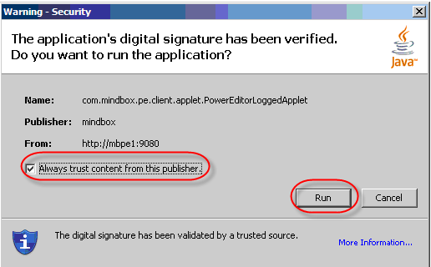
Figure 5-12 Security Warning
- At this point, you should see the PowerEditor login screen, shown below. The PowerEditor database is initially configured with one user.
  - Username: demo
  - Password: demo
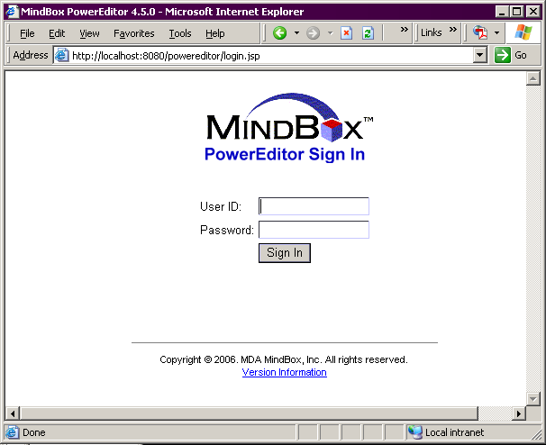
Figure 5-13 PowerEditor Login Screen

Client Installation Refinements
Here are some suggestions to help fine-tune certain client installations, ensuring that the PowerEditor window is not occluded or stomped on.

- Sometimes PowerEditor client performance can be tuned by increasing the amount of RAM pre-allocated to Java applications as the application is launched. In particular, if your PowerEditor feels very sluggish while others have no troubles, it could be a RAM allocation issue. This can be configured in your Java installation. It is recommended that you increase this to at least 256 MB.
  - For Java 1.6, go to your Windows Control Panel, and choose the Java Plug-In. In the Advanced tab, add the following:
-Xmx256m
  - For Java 1.5 go to your Windows Control Panel, and choose Java. The resulting dialogs are shown in the figures below. In the Java tab, under Java Applet Runtime Settings, choose the View button. Add the following line to the Java Runtime Parameters:
-Xmx256m
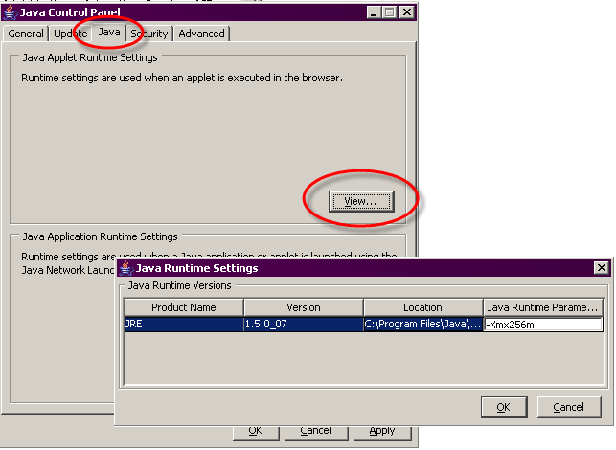
Figure 5-14 Java 1.5 Control Panel for Client Performance
- Bookmark the URL for the PowerEditor client.

- If links from other applications are configured open into the most recently opened window, the resulting window that's opened may end up in the PE browser, which will log you off of PE. For example, if you click on a browser link from an email, the web-page might pop up in your PowerEditor window. The fix is to set up the browser to always open links from other applications in a new window.

- If the browser is Firefox, and the client is a Windows configuration which has a permanent Taskbar at the bottom of the screen, configure Firefox to remove the status line from the bottom of Java applets.
- Go to Tools / Options / Content (click the Advanced button across from the Enable Java and Enable JavaScript checkboxes) and check the "Hide the status bar" box.

PE Client Installation Trouble-Shooting Suggestions
This section highlights potential difficulties in installing a PowerEditor client. If you find that this section does not address your issues, please contact MindBox Technical Support.

Connection Failure
If the PowerEditor login screen (Figure 5-13) does not appear, try some of the following:
- Try running the PE Validate Config tool from the client machine. Instructions for this are in Section 3.5 Server Configuration. In short, type the following in the browser:
http://<host>:<port-number>/powereditor/validate_config.jsp

- Make sure you can get to the host by pinging the host name. From a DOS window, type
ping <host>

- If you are trying to run the client from a server machine, you might encounter browser security issues. For example, in Internet Explorer, you might encounter the following dialog. Look at your browser options for security settings.
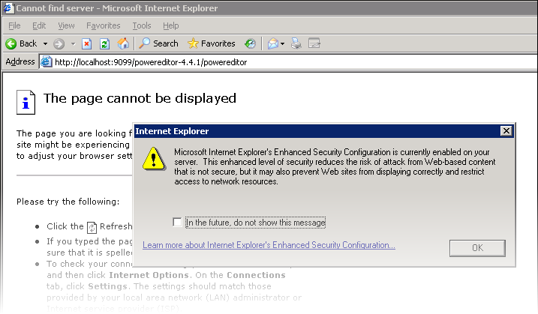
Figure 5-15 PE Client Blocked by Browser Security

- IE 7 security has the following security settings that need to be modified. Go to Tools->Internet Options->Security. Click on the Local intranet icon and click on sites. This will bring up a window that will allow you to add websites to the "Local Intranet" zone.
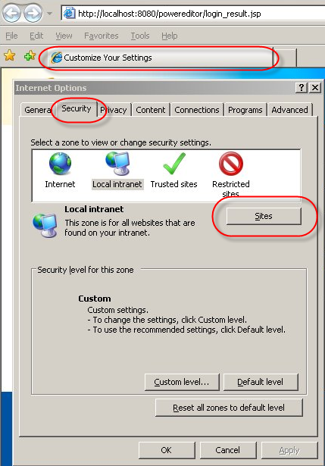
Figure 5-16 IE7 Security Settings

- If a new window is created, but has completely blank contents, it probably means that Java is not installed properly on the client machine. See Section 5.1 for more information. If you see the below screen after hitting the “Sign In” button, you can feel more confident that Java is installed.
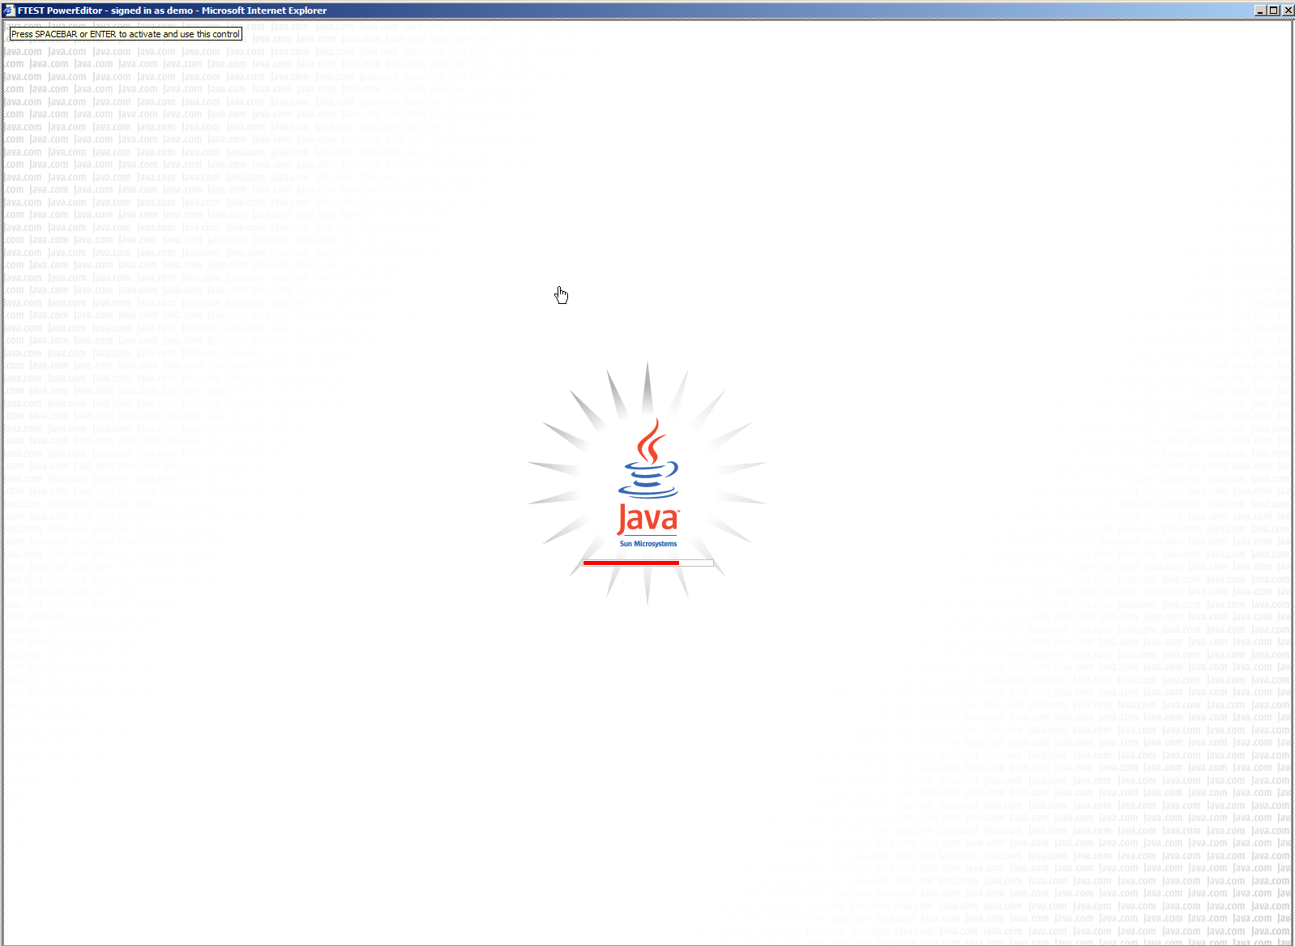
Figure 5-17 Indicates Proper Java Installation

- If you are really stuck, sometimes it is helpful to look at the log files on the server. Section 3.5 Server Configuration contains information about viewing log files.

Login Failure
Here are some issues that can occur after you’ve entered a username and password in the login screen (Figure 5-13).
- If pop-ups are not enabled, the PowerEditor will generate an error dialog. The following figure shows how that dialog appears in Internet Explorer (IE). Note that IE also presents its own dialog, and provides the control which allows you to enable pop-ups for this host.
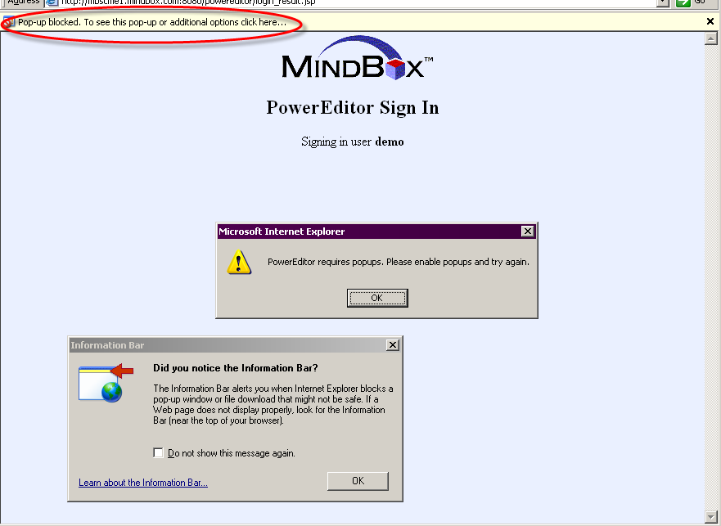
Figure 5-18 PE Client Blocked by Pop-Ups
- A login failure can sometimes be a symptom of server configuration issues: be sure to validate your configuration as described in Section 3.5 Server Configuration.
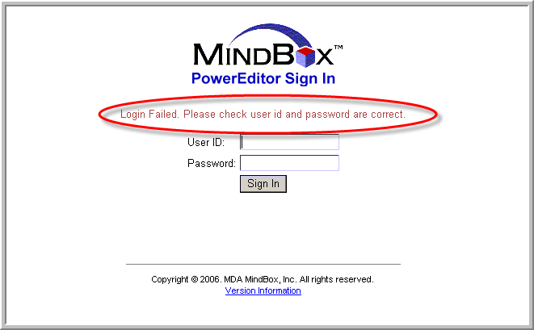
Figure 5-19 Potential Server Configuration Failure
- After logging in, the PowerEditor will create another window which will contain the applet. If that window is created but remains blank. In this case it might be useful to check the Java Console as is shown below. In the Java Console, look for errors:

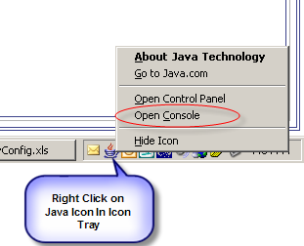
Figure 5-20 Checking Java Console for Client Configuration Error

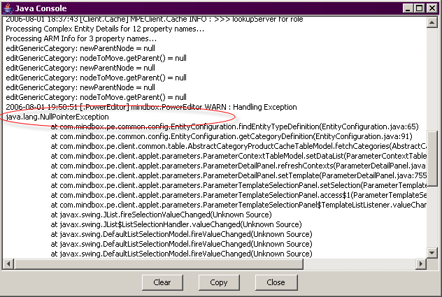
Figure 5-21 Java Console with Uncaught Configuration Error

Where are my Tabs?
If you find that the number of tabs are fewer than you expect, it's probably because the user you logged in doesn't have many (if any) permissions. Try logging in as demo/demo, then go to Admin->ManageUsers or Admin->ManageRoles.
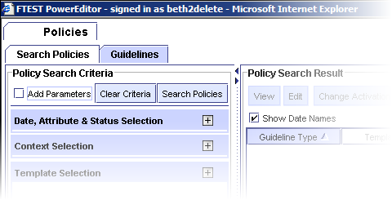
Figure 5-22 Login Result if User has no Roles or Privileges

PowerEditor Web Services API
The PowerEditor server is architected to allow custom-built client applications to programmatically access certain PowerEditor functions. For example, your site might want to initiate automatic nightly rule deploys from a custom built application rather than from the PowerEditor's manual user interface. Similarly, you might want to automatically synchronize your externally defined product database with PowerEditor product entities.

This chapter documents the application programming interface (API) provided by the PowerEditor for use by external client applications. Note that this section describes the API for data updates and functions only. Data queries can be performed by the Reporting API, as described in the document entitled PowerEditor Custom Reports Guide.

The PowerEditor currently provides external interfaces to the following functionality:
- Entity Import – Entities can be imported into the PowerEditor database, allowing you to synchronize externally stored data with the PowerEditor database.
- Rule Deploy - A rule deploy can be initiated from your external client application
- Data Export – Exporting data of any type can be initiated from your external application. For example, your application can initiate an entity export or a guideline export.

Any external client that wishes to update PowerEditor data will need to do so by accessing the PowerEditor Web Service interface. Web Services are independent of language, so the PowerEditor Web Service can be accessed from different types of clients. The PowerEditor Web Service has been specifically tested with Java and C# clients, and sample code for each of these clients is provided with the PowerEditor software distribution.

PowerEditor runs within a web application server such as Tomcat or Resin. When you launch the web application server, the PowerEditor server is launched, and listens for client requests. These requests can be from a PowerEditor web page (the typical client) or from a Web Services client.

To proceed The following approach is recommended for getting started using the Web Services API
- Test with Sample Client - Use the provided sample client application to test a round-trip client/server request
- Build Sample Client with Ping- Build or enhance your own sample client application to call the PowerEditor server with a simple ping request
- Build Real Client - Enhance your own client application to call the PowerEditor server with desired API calls (e.g. deploy, export, importEntities)
- Add Security - Change the server and client security as required for your installation.

Each step listed above is described in its own section below. The remainder of this chapter is quite technical, so if you aren't interested in the external API, you might want to skip on by.

Test with Sample Client
As mentioned above, the recommended first step in trying out the Web Service API is to use the provided sample client application to test a round-trip client/server request. The distributed client application is a Java client. You'll need to run this client application on the same machine that runs the PowerEditor server. Specifically, for the distributed client to work, the following URL must be valid – try typing it into your browser to see that it doesn't return an error:
http://localhost:8080/powereditor/PowerEditorWebService?wsdl

The PowerEditor.zip file contains a folder called wsclient. For the purpose of this discussion, let's assume you unzipped this into a folder called \mindbox\PowerEditor\wsclient.

Call Ping with Sample Client
To call the PowerEditor server ping function from the sample Java client, perform these steps:
- Make sure the PowerEditor server is running
- On the PowerEditor server machine, open a command window (e.g. a DOS window or shell window)
- Change to the wsclient directory. For example:
cd \mindbox\PowerEditor\wsclient
- Run the test client by typing
run-wsclient ping
- Verify that the client returns a success message. For example,
[RESULT] Ping command received and processed.

Call Other Functions with Sample Client
After you've successfully called ping, you might want to try calling some of the other API functions using the sample client. Although this step is optional, it could be fun to try, and could prove a useful debugging technique as you build and debug your own client application. Here are examples of other functions you can invoke using the sample API from the command line:
- run-wsclient ping
- run-wsclient import <filename> [username] [password]
- run-wsclient export <filename> [username] [password]
- run-wsclient deploy [username] [password]

If you type in run-wsclient all by itself (with no arguments) documentation for this tool will be displayed.

Note that the API for import, export, and deploy functions include many optional parameters, as described in Section 6.5 Client API Technical Specifications. For example, you could specify what usage-types to deploy, or what activation dates to export. These parameters can be passed into the run-wsclient application by editing the following file:
wsclient\pewsclient.properties

Build Test Client
After you've successfully invoked ping with the distributed sample client application, you'll want try invoking ping from your own client application. This document assumes that you know how to build a client application in the language you desire, and this section is intended to demonstrate how the ping function could be invoked from your client.

Building Java Client
To build a Java client, you'll need the following:
- Java JDK 1.6.0 or higher

Source code for a sample Java application is provided with the PowerEditor distribution. This is in the PowerEditor.zip file under wsclient\java\PEWSClient.java. You'll want to examine this file at this time. The interesting lines of code to look at in this file are:

import com.mindbox.test.pe.webservices.wsimportgen.PowerEditorAPIInterface;
import com.mindbox.test.pe.webservices.wsimportgen.PowerEditorAPIInterfaceService;
import com.mindbox.test.pe.webservices.wsimportgen.PowerEditorInterfaceReturnStructure;

PowerEditorAPIInterface peAPIInterface =
new PowerEditorAPIInterfaceService().getPowerEditorAPIInterfacePort();

PowerEditorInterfaceReturnStructure peirs = peAPIInterface.ping();

String pingResponse = peirs.getContent();

When building your application, you will need to make sure that the WSDL location is set properly. This is the location of the Web Services Definition Language definition that can be accessed when PowerEditor is installed and is running. The following is an example of setting the WSDL location to a PowerEditor server running on localhost on port 8080:

wsdl.location = http://localhost:8080/powereditor/PowerEditorWebService?wsdl

Your Java client will most likely need to use the following JAR files, which are distributed with the PowerEditor:
- saaj-impl.jar
- xws-security.jar

Building C# Client
Source code for a sample C# application is provided with the PowerEditor distribution. This is in the PowerEditor.zip file under wsclient\csharp\PEWSClient.cs. You'll want to examine this file and (other files in this directory) at this time. The interesting lines of code to look at in this file are:

localhost.PowerEditorAPIInterfaceService CallWebService =
new localhost.PowerEditorAPIInterfaceService();

PEWSClient.localhost.powerEditorInterfaceReturnStructure pingResult = CallWebService.ping();

Console.WriteLine("Result content: {0}", pingResult.content);

When building your application, you will need to make sure that the WSDL location is set properly. This is the location of the Web Services Definition Language definition that can be accessed when PowerEditor is installed and is running. The following is an example of setting the WSDL location to a PowerEditor server running on localhost on port 8080:
http://localhost:8080/powereditor/PowerEditorWebService?wsdl
The general format of the WSDL location is
http://host:port/powereditor/PowerEditorWebService?wsdl

For example, if you create a new “Console Application”, in the right pane (Solution Explorer) click the right button and select "Add Web Reference". Enter the WSDL location as described above.

Building a Different Client
Read the sections above to get a general feel for things, then use the functions specified Section 6.5 Client API Technical Specifications.

Build Real Client
After you've built a client that calls ping you are ready to call the real API function you want to use. Specifically you can write your client to call one of the following functions:
- deploy
- importEntities
- exportData

As mentioned above, these functions can be called with filtering options, such as usage-types, dates, or status values. These are all described in Section 6.5 Client API Technical Specifications.

Note that the functions listed above provide require unencrypted username and passwords, which the level of encryption you'll want as you get started. After you get these calls to work as you'd like, then you'll then consider what security features best suit your application. Security is described in the following section.

Client API Security Levels
The PowerEditor Web Service can be configured to use 3 levels of security:
- Unencrypted Credentials
- Encrypted Credentials
- HTTPS Encryption

Unencrypted Credentials
By default, the PowerEditor Web Service is configured to accept client requests requiring unencrypted credentials. This level of security is usually fine for installations where the client application and the server are co-located.

When the PowerEditor is configured for no encryption, your client should call the "encryption-free" API functions. For example, you should call the function deploy rather than deployWithCredentials.

Encrypted Credentials
An option for higher security is to configure the PowerEditor server to require the username/password credentials in the header of the request that it receives from the client. This information would be passed in the SOAP header. The password will have an authentication level of “Basic” which means that it will be encrypted but with a low-level algorithm.

The PowerEditor server can be configured to require encryption by modifying the handlers.xml file. See the technical specification section below for more detail.

When you configure the PowerEditor to require this level of security, then your application will need to call the PowerEditor functions intended for security. For example, you should call deployWithCredentials rather than deploy. Calling the encryption-free functions when this level of security is required will result in an error. For example, if you call deploy when encrypted credentials are required, an error message will be returned stating that required credentials are not found in the SOAP header.

Although using encrypted credentials provides some security, the downside of this approach is that it adds a fair amount of complexity to the client, and the security gained is not that high.

HTTPS
The strongest security requires adding a “certificate” for use with the application server and setting it up to listen for secure requests so that it speaks secure HTTP (HTTPS). This level of security is rarely required, since the PowerEditor API will rarely be required over a public DNS. Although the PowerEditor Web Service API can be run with HTTPS, it requires an application server change, and is not documented here.

Client API Technical Specifications

Requiring Encrypted Credentials
As mentioned above the PowerEditor server can be configured to require the username/password credentials in the header of the request that it receives from the client. To enable this option, edit the following file in your PowerEditor installation and uncomment out the code so that it looks like the highlighted section:

File: webapps\powereditor\WEB-INF\classes\handlers.xml
<jws:handler-chains xmlns:jws="http://java.sun.com/xml/ns/javaee">
<jws:handler-chain name="MyHandlerChain">
<jws:handler>
<jws:handler-class>
com.mindbox.pe.server.webservices.PowerEditorAPISecurityHandler
</jws:handler-class>
</jws:handler>
</jws:handler-chain>
</jws:handler-chains>

Now, when the application server is restarted, there is a new process that will run that “intercepts” the request as it is coming in, but before the function is called, that checks the username and password against the PowerEditor database.

Debugging Options: You can configure the PowerEditor server to set the messages to dump to the output. The file and its contents are below:

File: webapps\powereditor\WEB-INF\user-pass-authenticate-server.xml
<xwss:SecurityConfiguration xmlns:xwss="http://java.sun.com/xml/ns/xwss/config" dumpMessages="false" >
<xwss:RequireUsernameToken passwordDigestRequired="false"/>
</xwss:SecurityConfiguration>

Web Service Methods
If you've configured your PowerEditor server to run without requiring encryption, then the following methods are available to you:
- deploy
- importEntities
- exportData
- ping

If you've configured your PowerEditor server to require encryption, then the following methods are available to you:
- deployWithCredentials
- importEntitiesWithCredentials
- exportDataWithCredentials

The remainder of this section lists the function headers for these functions.

Deploy API
If you'd like to initiate the deployment of rules and/or parameters from your client, then use either the deploy or deployWithCredentials function. Invoking this function is equivalent to hitting the Deploy button from the PowerEditor user interface – output files will be generated as specified by your PowerEditor configuration file. (See Section 7.5.4 Deployment for a detailed description of the location of output files during deploy).

Note that sometimes the deploy function can take a long time. This is a blocking, synchronous function, so the function won't return until the deploy process is complete.

public PowerEditorInterfaceReturnStructure deploy(
String status,
String[] usageTypes,
boolean deployGuidelines,
int[] guidelineTemplateIDs,
boolean deployParameters,
int[] paramTemplateIDs,
boolean useDaysAgo,
int daysAgo,
String activeOnDate,
boolean includeEmptyContexts,
boolean includeParentCategories,
boolean includeChildrenCategories,
boolean includeProcessData,
boolean includeCBR,
boolean includeEntities,
String contextElements
)

public PowerEditorInterfaceReturnStructure deployWithCredentials(
String status,
String[] usageTypes,
boolean deployGuidelines,
int[] guidelineTemplateIDs,
boolean deployParameters,
int[] paramTemplateIDs,
boolean useDaysAgo,
int daysAgo,
String activeOnDate,
boolean includeEmptyContexts,
boolean includeParentCategories,
boolean includeChildrenCategories,
boolean includeProcessData,
boolean includeCBR,
boolean includeEntities,
String contextElements,
String userID,
String password)

The arguments to the deploy functions closely match the deploy options presented in the PowerEditor user interface. These arguments are as follows:
status This string must be the internal name of a valid PowerEditor status. The PowerEditor will deploy guidelines and parameters of all statuses at this level and above.
deployGuidelines true/false – The value true indicates that guidelines shall be deployed.
guidelineTemplateIDs Array of guideline template IDs. A null value indicates that all guidelines for all templates shall be deployed, unless deployGuidelines=false.
deployParameters true/false – The value true indicates that parameters shall be deployed.
paramTemplateIDs Array of guideline template IDs. A null value indicates that all guidelines for all templates shall be deployed, unless deployGuidelines=false.
useDaysAgo true/false – whether or not the daysAgo argument will be used
daysAgo number of days before the current day that expired rules and parameters will be deployed.
activeOnDate A date string of the following format: yyyy-MM-dd hh:mm:ss. Only guidelines and parameters that are active on the given date will be deployed.
includeEmptyContexts This true/false argument is only relevant if the contextElements argument is used. A value of true specifies that guidelines with blank contexts should be included in the results.
includeParentCategories This true/false argument is only relevant if the contextElements argument is used. A value of true specifies that the resulting guidelines should include ones whose context contain parent categories of the provided context elements.
includeChildrenCategories This true/false argument is only relevant if the contextElements argument is used. A value of true specifies that the resulting guidelines should include ones whose context contain children categories/ entities of the provided context elements.
includeProcessData This true/false argument specifies whether data from the Manage Process Data tab will be deployed. Process data includes phase and request objects. Note that many PowerEditor installations have this tab hidden, in which case the value of this argument doesn’t matter.
includeCBRData This true/false argument specifies whether data from the Manage CBR Data tab will be deployed. CBR is Case-Based Reasoning. Note that many PowerEditor installations have this tab hidden, in which case the value of this argument doesn’t matter.
includeEntities This true/false argument specifies whether the entities.xml file will be generated as part of this deployment.
contextElements This string of comma separated entity IDs narrows the list of guidelines returned to those whose context includes the specified entities/categories. If categories are specified the guidelines returned will be those that appear in all the categories specified (i.e. AND logic is used).
Each comma-separated value must be one of the following formats:
<entity-type>:entity:<entity-name>
<entity-type>:category:<category-name>

Example:
product:entity:FNMA Conforming Fixed 15
product:category:Fixed
product:category:Fixed,product:category:Conforming

If the category names in your application are not unique they can be fully qualified with the “->” separator. For example:
product:category:Root->AmTerm->Fixed
userID A user ID for a user that has deploy privileges. (This argument is only valid for the deploy function – not the deployWithCredentials function).
password The user's password, unencrypted. (This argument is only valid for the deploy function – not the deployWithCredentials function).

Importing Entities API
If you would like to import entity definitions from your client into the PowerEditor database, use one of importEntities or importEntitiesWithCredentials. The entities to be imported are specified in the content argument to this function. The content is a string that is contains entity XML. The XSD specification for this XML string is specified in the following file: webapps/PowerEditor/resources/PowerEditorData.xsd. You should only need to use the <Entities> section of the XSD.

public PowerEditorInterfaceReturnStructure importEntities(
String content,
boolean merge)

public PowerEditorInterfaceReturnStructure importEntitiesWithCredentials(
String content,
boolean merge,
String username,
String password)

The arguments to the deploy functions closely match the deploy options presented in the PowerEditor user interface. These arguments are as follows:
content The content is a string that is contains entity XML. The XSD specification for this XML string is specified in the following file: webapps/PowerEditor/resources/PowerEditorEntityData.xsd.

merge true/false – The merge option provides a means for merging two completely independent KBs.
- The value true indicates that the imported values are treated independently from pre-existing values, which means that new identifiers will be created for all imported entities, ensuring that no overlapping IDs will occur.
- The value false indicates that you are not merging independent KBs, therefore entity IDs will be preserved. If you are importing an entity that uses the same ID as an entity that is already in the PowerEditor, the existing PowerEditor entity will be replaced with the entity that is being imported.

Export API
To have the PowerEditor generate an export XML file, use the exportData or exportDataWithCredentials function. Most of the arguments are documented in the Deploy API section above.

Note that sometimes the export function can take a long time. This is a blocking, synchronous function, so the function won't return until the export process is complete.

public PowerEditorInterfaceReturnStructure exportData(
boolean exportEntities,
boolean exportSecurity,
boolean exportGuidelines,
boolean exportParameters,
boolean exportTemplates,
boolean exportGuidelineActions,
boolean exportTestConditions,
boolean exportDateSynonyms,
boolean includeEmptyContexts,
boolean includeParentCategories,
boolean includeChildrenCategories,
String status,
String[] usageTypes,
int[] guidelineTemplateIDs,
int[] paramTemplateIDs,
boolean useDaysAgo,
int daysAgo,
String activeOnDate,
String contextElements)

public PowerEditorInterfaceReturnStructure exportDataWithCredentials(
boolean exportEntities,
boolean exportSecurity,
boolean exportGuidelines,
boolean exportParameters,
boolean exportTemplates,
boolean exportGuidelineActions,
boolean exportTestConditions,
boolean exportDateSynonyms,
boolean includeEmptyContexts,
boolean includeParentCategories,
boolean includeChildrenCategories,
String status,
String[] usageTypes,
int[] guidelineTemplateIDs,
int[] paramTemplateIDs,
boolean useDaysAgo,
int daysAgo,
String activeOnDate,
String contextElements,
String userID,
String password)

Ping

public PowerEditorInterfaceReturnStructure ping()

PowerEditor Customization Guide
The PowerEditor includes many options for customizing the tool to suit the needs of each installation of the tool. For example, entities can be renamed, tabs can be turned off, and rule generation can be configured for specific rule engines. The following two chapters present the many options that the PowerEditor provides for customization.

The first of these two chapters, Chapter 7: PowerEditor Customization Guide serves as a relatively in-depth discussion of each of the customizable options. It includes extensive verbiage, diagrams and examples. The subsequent chapter, Chapter 8: Configuration File Reference presents a table summary of configurable options.

The configurable properties of the PowerEditor are maintained in a centralized location: the PowerEditorConfiguration.xml file. This file is located in the directory specified in the <webapps>/web.xml file associated with your PowerEditor installation. This file is sometimes loosely referred to as “the config file”. All configuration options presented in the next two chapters are from this file, unless otherwise noted.

High-Level Tab Configuration
There are some high-level tabs, a.k.a. features, which can be disabled for a configuration. These tabs are:
- Case-Based Reasoning
- Parameters (appears under Policies tab)
- Manage Process

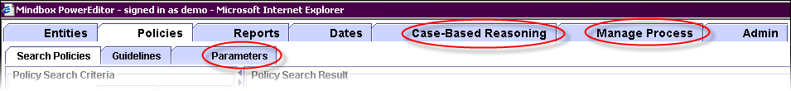
Figure 7-23 Configurable Features

To turn off a feature, set the enable attribute to “false” in the following section in the config file. Note that if a feature is not present in the config file, the feature will be enabled by default.

<FeatureConfig>
<Feature name="cbr" enable="false" className="com.mindbox.pe.client.applet.cbr.CBRPanel"/>
<Feature name="parameter" enable="true"
className="com.mindbox.pe.client.applet.parameters.ParameterManagerTab"/>
<Feature name="phase" enable="true"
className="com.mindbox.pe.client.applet.admin.ProcessManagementTab"/>
</FeatureConfig>
Figure 7-24 Feature Configuration Section of PowerEditorConfiguration.xml

Note that other tabs are also configurable, but appear in separate sections of the configuration file, and are therefore discussed later in this document. Such tabs include:
- Tabs that appear under the entity tab
  - Manage Products
  - Manage Channels
  - Manage Compatibility

Also note that some tabs may be disabled based on user permission. The mechanism for disabling tabs based on user permission is discussed in the document entitled PowerEditor User’s Guide. Examples of tabs that are disabled based on user permission are:
- Manage Guideline Test Conditions
- Manage Guideline Actions
- Manage Roles
- Manage Users

Entity Configuration

Entity Configuration Overview
Entities are objects that can appear in the context of guidelines. They represent basic central business concepts that are commonly associated with business policies. Entity Types are the types of objects that can appear in the context of guidelines. Examples of entity types in the mortgage domain include products, programs, channels and investors. For a more thorough conceptual description of entities, see the PowerEditor User’s Guide.

All Entity management functionality of the PowerEditor is available in the Entities tab. You may configure the Entities tab to contain any number of entity types. For each entity type, you can also configure the following:
- The entity properties that are available for each type of entity
- The entity property tab under which each property appears
- Whether each entity property is searchable
- Whether the entity property appears as a column in the entity selection table
- Whether categories are available for the entity type
The following figure shows how each of the configurable elements are displayed in the PowerEditor.

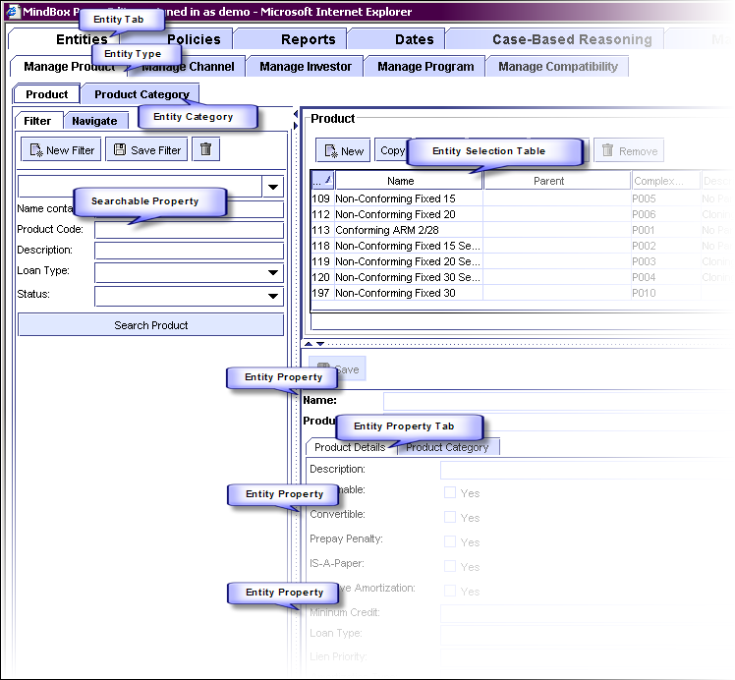
Figure 7-25 Configurable Entity Elements
The remainder of this section describes how to configure these entity elements. The PowerEditor separates entity type information into the areas listed below. In order to add a new entity, you need to create configuration elements in each area.
1) Entity Definition: Defines the category, entity, and properties, at the PowerEditor modeling level. This information is specified in the <EntityConfig> section of the config file. This section of the config file is documented in Section 7.2.2 Entity Definition.
2) Entity Display Defines which entity types and attributes will be displayed in the PowerEditor. This information is specified in the <UserInterface><Entity> section of the config file. This is documented in Section 7.3.1 User Interface: Entity Display.
3) Entity Rule Mapping Defines information relevant to how entities map into the Mortgage Domain objects at rule generation time. This information is specified in the <RuleGeneration><LHS><Pattern> section of the config file. It makes reference to information in the Domain file. This is documented in Section 7.4.1.2 LHS Control Pattern.
4) Entity Parameter Mapping Defines information relevant to how entities map into the Mortgage Domain objects for parameters at rule generation time. This information is specified in the <RuleGeneration>< ObjectGenerationDefault> section of the config file. It makes reference to information in the Domain file. This is documented in Section 7.4.4 Parameter Generation Options.
5) Entity Domain Model The definition of the entity and attributes in the Mortgage Domain file. This information is contained wholly within the Domain file.
Figure 7-26: Entity Definition Components
So, if you want to add a new entity to your configuration, and you’d like for that entity to be used in rule and parameter contexts, then you would need to modify each of the above components of your PowerEditor configuration file. It would probably be great to have a step-by step example of doing this, but that’s a great fantasy of documentation to come. For now, look at the section references listed in the box above.

Entity Definition
As mentioned in the above overview, entity definition is achieved in the <EntityConfig> section of the config file. This section provides a conceptual overview of the EntityConfig section. For a detailed description of each element, see Section 8.2: Summary of Entity Configuration Parameters.

<EntityConfig>

<CategoryType name="Product Category" typeID="10" showInSelectionTable="Yes"/>
<CategoryType name="Program Category" typeID="40"/>

<EntityType name="product" displayName="Product" typeID="0" useInContext="Yes"
useInCompatibility="Yes" canClone="Yes" categoryType="10">
<EntityProperty name="code" displayName="Product Code" showInSelectionTable="Yes"
isRequired="Yes" isSearchable="Yes" type="string"/>
<EntityProperty name="description" displayName="Description" showInSelectionTable="Yes"
isRequired="No" isSearchable="Yes" type="string"/>
<EntityProperty name="assumable" displayName="Assumable" showInSelectionTable="No"
isRequired="No" isSearchable="No" type="boolean"/>
</EntityType>

<EntityType name="program" displayName="Program" typeID="7" useInContext="Yes" useInCompatibility="Yes" canClone="yes" categoryType="40" >
<EntityProperty name="description" displayName="Description" showInSelectionTable="No"
isRequired="No" isSearchable="Yes" type="string"/>
<EntityProperty name="code" displayName="Code" showInSelectionTable="Yes"
isRequired="No" isSearchable="Yes"
type="enum" enumType="program.code" sort="Yes"/>
</EntityType>

<EntityConfig>
Figure 7-27 Sample EntityConfig Section of Config File
Three major elements are defined in the EntityConfig section: Categories, Entity Types, and Entity Properties.

CategoryType
This element defines a category, which will later be associated with an entity. To see an example of this association, see the bold items in Figure 7-27 Sample EntityConfig Section of Config File.

If you want to have a category hierarchy associated with an entity type:
- Add a <CategoryType> element , with a typeID
- Add the typeID to the appropriate <Entity> categoryType element

To disable category support for an entity, do not supply a categoryType for that entity.

EntityType
This configuration element defines an entity type (e.g. Product, Program). It is used to specify how the entity type will be displayed and edited, including its display name, editable properties, and selection table. Specific configuration elements are as follows.

name The internal name of the entity type. This serves as an identifier for the entity type. This identifier is used throughout the config file when referencing the entity type.
displayName Name displayed in the PowerEditor UI.
typeID A unique ID.
useInContext Specifies whether this entity get displayed in the guideline context selection.
useInCompatibility Specifies whether this entity get displayed in the compatibility matrix
canClone Specifies whether the clone button is enabled for this entity. Cloning an entity puts the new entity in the context of all the guidelines that have the old entity
categoryType The typeID associated with the category hierarchy for this entity. This must match a value in CategoryType typeID
useInMessageContext Template messages can be associated with an entity type. For example, in mortgage applications, messages are sometimes associated with the channel entity type. For a given installation, messages can be associated with at most one entity type. This means that useInMessageContext can be set to yes for at most one entity type.

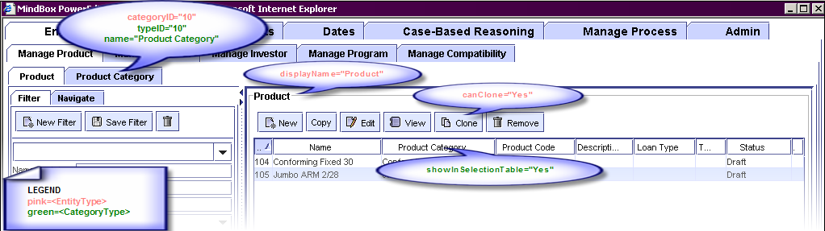
Figure 7-28 CategoryType and EntityType Elements

uniqueCategoryNames Specifies whether categories for this entity type should have unique names. If this is Yes, then the PowerEditor enforces unique category names for this entity type. See dialog below.
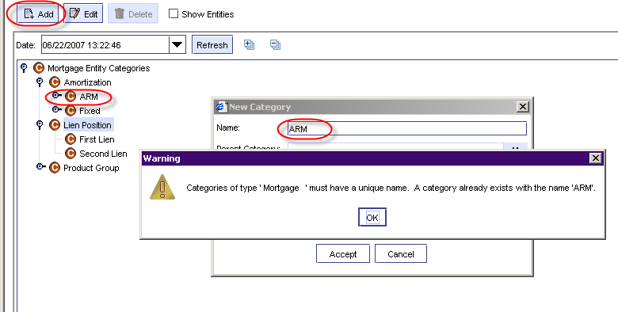
Figure 7-29 Creating Duplicate Node Names for Entity with uniqueCategoryNames

EntityProperty
The EntityProperty configuration element defines properties, or attributes, associated with a given EntityType. Entity Properties are editable fields that are displayed on the entity screen. See Figure 7-23 Configurable Features for some example Entity Properties. You might notice that Entity Properties can appear within a Property Tab, or above the property tabs (as highlighted in Figure 7-30 EntityProperty Elements). This is controlled in the <UserInterface> section of the config file, to be described in a later section.

Each PowerEditor EntityType comes predefined with two entity properties: id and name.

For each entity property, you can specify its field type, whether it is required, whether it appears in the selection table, and whether it appears in the search panel. These configurable elements are highlighted in Figure 7-30 EntityProperty Elements.
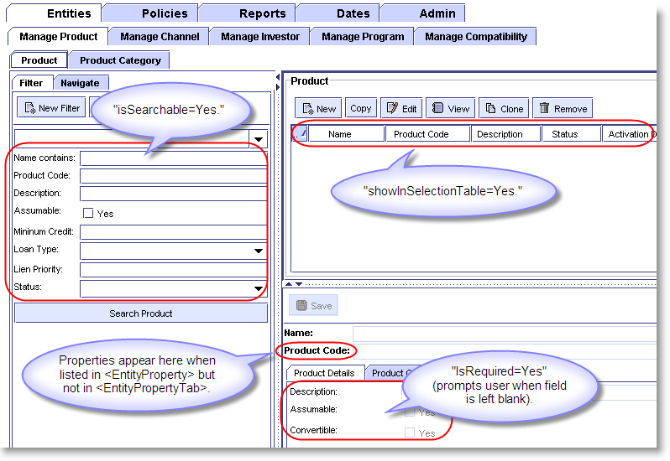
Figure 7-30 EntityProperty Elements
name The internal name of the property. This serves as an identifier for the entity type. This identifier is used throughout the config file when referencing the property. The value of this cannot be id or name, since these are predefined attributes automatically associated with each entity type.
displayName Name displayed in the PowerEditor UI.
showInSelectionTable Specifies whether this property is shown in the Product Selection pane.
isRequired Specifies whether the property's value must be filled in prior to saving. If the user attempts to save an entity without filling in a required field, they will receive an error. Required properties appear in bold.
isSearchable Specifies whether users can search by that property, and it appears in the Filter pane.
type The field type for the property. Valid values are: enum, string, boolean, symbol, integer, long, currency, percent, float, double, date.
enumType Valid only when type=enum and when attributeMap is not used. Specifies a database table in which enumerated values are listed.
attributeMap Valid only when type=enum and when enumType is not used. This specifies a pointer to an enumerated list that is in the domain file. This needs to be a DomainClass.DomainAttribute reference. For example,
attributeMap=”LDO_LOAN_FEATURES.LoanDocumentationType”.
sort Valid only when type=enum. Specifies whether the PE should sort the enumerated values.
autoUpdatedDateProperty Valid only when type=date. Specifies that this date will be automatically updated whenever the specified property changes. For example, if autoUpdatedDateProperty=”Status” then whenever the Status property is edited, this date property will be automatically updated to the time that the Status property was changes.
allowMultiple Used only when type is “enum”. This allows multiple selection of values for the given property. This feature is added in version 5.6.0. Note that export of multi-select properties are written as a vertical var (‘|’) separated list of values.

Important Note: As mentioned above, the value of the EntityProperty name cannot be id or name, since these are predefined attributes automatically associated with each entity type.
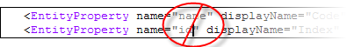
Figure 7-31 Illegal values for EntityProperty name

User Interface Customization
This provides the ability to customize the PowerEditor User Interface for the specific application. The PowerEditor User Interface consists of two major components: Entity management and Guideline management. They are discussed below.

User Interface: Entity Display
As mentioned in the Entity Configuration Overview (Section 7.2.1), there are 5 components used to define an entity. To review:
1) Entity Definition: Defines the category, entity, and properties, at the PowerEditor modeling level.
2) Entity Display Defines which entity types and attributes will be displayed in the PowerEditor.
3) Entity Rule Mapping Defines information relevant to how entities map into the Mortgage Domain objects at rule generation time.
4) Entity Parameters Mapping Defines information relevant to how entities map into the Mortgage Domain objects for parameters at rule generation time.
5) Entity Domain Model The definition of the entity and attributes in the Mortgage Domain file.
This section of the document describes the second component of entity configuration: Entity Display.

Entity Display is controlled in the <UserInterface><Entity> section of the PowerEditorConfiguration file. For a given entity type, you can specify which entity properties will be displayed, the order of the properties displayed, and the sub-tabs in which the properties will be displayed.

The following two figures show an example of configuring an entity display. For more details on the XML specification for the <UserInterface><Entity>, see Section 8.3 Summary of UI Configuration Parameters.

<UserInterface>
<Entity showTab="Yes">
<EntityTab type="product" showTab="Yes">
<EntityPropertyTab title="Product Details">
<EntityPropertyName>amortization.type</EntityPropertyName>
<EntityPropertyName>amortization.terms</EntityPropertyName>
<EntityPropertyName>interest.only</EntityPropertyName>
....
</EntityPropertyTab>
<EntityPropertyTab title="Arm Info">
<EntityPropertyName>arm.index.name</EntityPropertyName>
<EntityPropertyName>arm.first.adjust.period</EntityPropertyName>
<EntityPropertyName>arm.later.adjust.period</EntityPropertyName>
</EntityPropertyTab>
</EntityTab>
</Entity>
Figure 7-32 Sample Entity Section of Config File

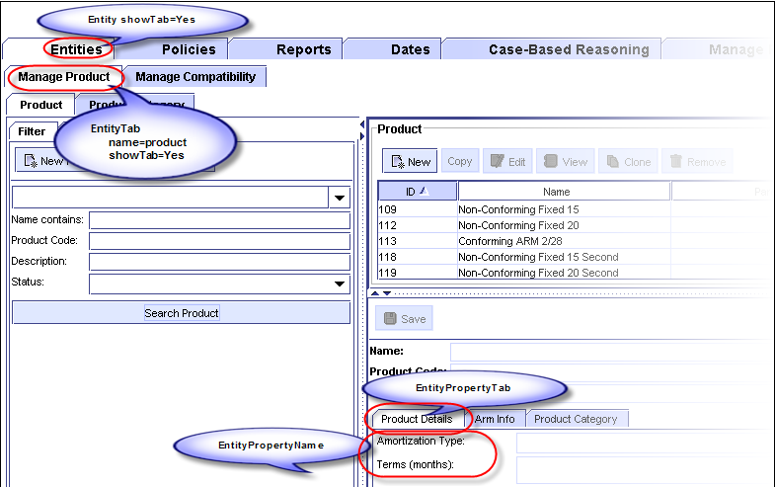
Figure 7-33 UserInterface Entity Elements
Note that properties specified in the EntityType that have showInSelectionTable="Yes" will show up in the Product details pane whether listed under an EntityPropertyTab or not.

User Interface: Usage Type List
PowerEditor is configured with a set of usage types. Usage types are used to group like guidelines together, as well as, to provide context for phases. Each usage type is declared as <UsageType> tag in the <UserInterface><UsageTypeList> section. In addition, each usage type defined in the <UsageTypeList> must be included in the <UserInterface><GuidelineTab> declaration, in order to be recognized by the application. Refer to Section 7.3.3 for more details on the GuidelineTab section.

User Interface: Guideline Management

Guideline Tabs
The <UserInterface><Guideline> section is used to define groupings of Usage Types within the Manage Guidelines screen.

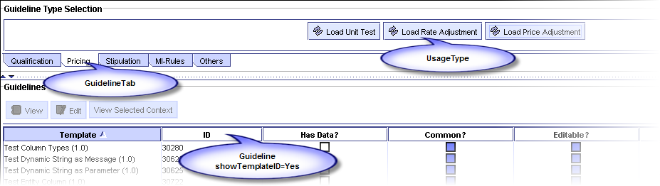
Figure 7-34 GuidelineTabs and UsageTypes
<UserInterface>
<UsageTypeList>
<UsageType name="Global-Qualify" displayName="Global Qualify" privilege="QualificationData"/>
<UsageType name="Product-Qualify" displayName="Product Qualify" privilege="QualificationData"/>
<UsageType name="Deal-Qual" displayName="Deal Qualification" privilege="QualificationData"/>
<UsageType name="Unit-Test" displayName="Unit Test" privilege="PricingData"/>
<UsageType name="Rate-Adjustment" displayName="Rate Adjustment" privilege="PricingData"/>
<UsageType name="Price-Adjustment" displayName="Price Adjustment" privilege="PricingData"/>
<UsageType name="Stipulation" displayName="Stipulation" privilege="QualificationData"/>
....
</UsageTypeList>

<Guideline showTemplateID="Yes">
<GuidelineTab displayName="Qualification">
<UsageType name="Global-Qualify"/>
<UsageType name="Product-Qualify"/>
<UsageType name="Deal-Qual"/>
</GuidelineTab>
<GuidelineTab displayName="Pricing">
<UsageType name="Unit-Test"/>
<UsageType name="Rate-Adjustment"/>
<UsageType name="Price-Adjustment"/>
</GuidelineTab>
....
</Guideline>
Figure 7-35 Sample UserInterface Guideline Section of Config File

Sorting Enumerated Values
Enumeration values of a single-select or multi-select enum column can be sorted or not, based either on the global configuration or the Sort Enum Values attribute associated with each column in the Guideline Template. To globally configure sorting, set the “sortEnumValue” attribute of the <Guideline> tag to “Yes”, as shown below:
<PowerEditorConfiguration>
<UserInterface>
<Guideline showTemplateID="Yes" sortEnumValue=”Yes”>
. . .

To override the global setting on a column by column basis, use the column definition in the Guideline Template.
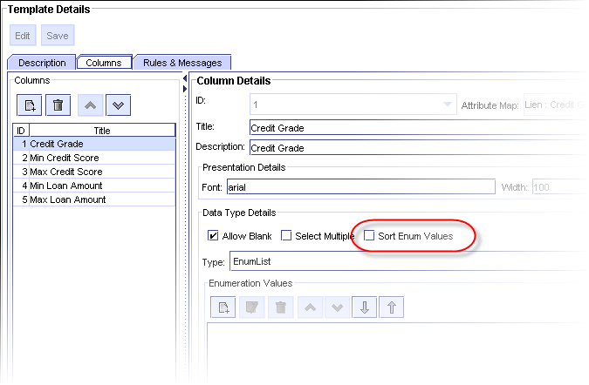
Figure 7-36 Overriding sortEnumValues

Fit Grids to Screen
PowerEditor, by default, displays grids in full size; the width of the grid is the sum of the width of each column in the grid. Typically, this sum is wider than the screen width. To accommodate this, you can instruct PE to shrink the grid to fit to the screen or not. To fit all grids to the screen width, set the “fitGridToScreen” attribute of the <Guideline> tag to “Yes”, as shown below:
<PowerEditorConfiguration>
<UserInterface>
<Guideline showTemplateID="Yes" fitGridToScreen=”Yes”>
. . .

If this attribute is set to “No” or not specified, PE will display all grids in full width.
Note that each guideline template also has “fitToScreen” attribute. The value set in each guideline template overrides the option specified in the PowerEditorConfiguration.xml.
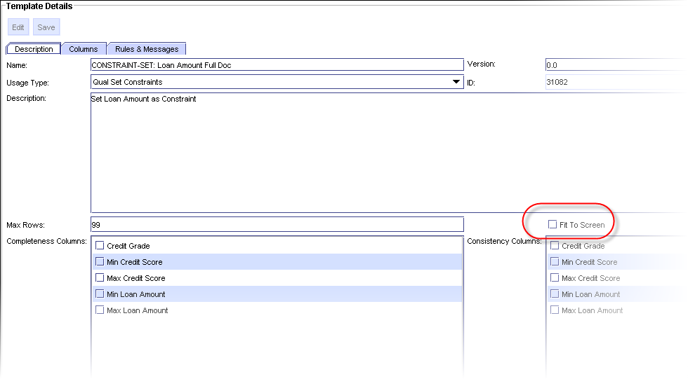
Figure 7-37 Overriding fitGridToScreen

User Interface: Miscellaneous Options
The following provides a brief overview of other User Interface options:

<DateSynonym>
<DefaultTime>00:00</DefaultTime>
</DateSynonym>

<DeployExpirationDate>
<DefaultDays>30</DefaultDays>
</DeployExpirationDate>

<ClientWindowTitle>MindBox PowerEditor</ClientWindowTitle>

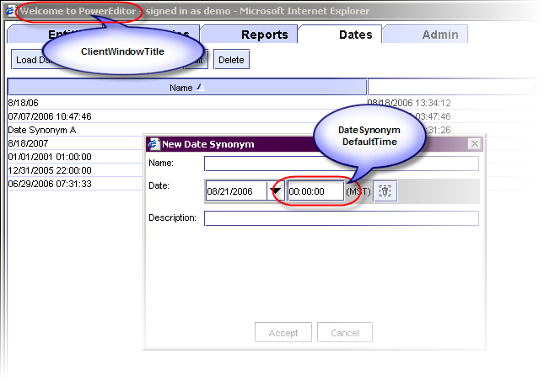
Figure 7-38 Date Synonym Default and Client Window Title Options

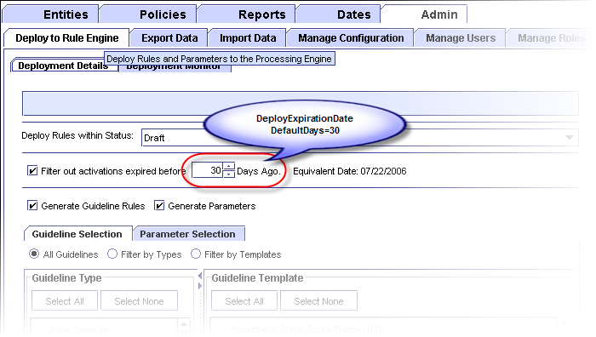
Figure 7-39 Deploy Expiration Date Option

User Interface: Policy Management

Enforcing Sequential Activation Dates
PowerEditor gives you the option to enforce that all activation dates for a template and context are contiguous are non-overlapping.

<UserInterface>
<UIPolicies>
<EnforceSequentialActivationDates>Yes</EnforceSequentialActivationDates>
</UIPolicies>
…

Rule Generation Options
The format of the ARTScript rules generated by the PowerEditor is controlled within the Rule Generation section of the configuration file. Rule generation options can be specified for the entire configuration using the <RuleGenerationDefault> element, and then can be overridden for each usageType. Separate elements are provided for LHS specification, RHS specification, message generation and parameter generation.

LHS Options
The LHS of each AE rule generated by the PowerEditor begins with a request pattern and a control pattern. The request pattern is the first pattern in the rule and describes the state of the engine in which the rule is intended to fire. The control pattern follows the request pattern and describes the contextual objects against which the rules fire. These patterns are each described below.

LHS Request Pattern
As mentioned above, the request pattern appears on the LHS of all rules generated by the PowerEditor. This pattern contains information about the state that the engine needs to be in for the rule to fire. For example, it contains information like the applicable focus of attention, and the date for which the rule applies.

The format of the request pattern is controlled by the following line in the LHS section of the configuration file:

<Pattern type="request" generate="Yes" class="phase" prefix="pa:" usageTypeAsFocus="Yes"/>
Figure 7-40: Configuration XML for Request Pattern

type Type=”request” specifies that the request pattern is being configured by the remaining attributes.
generate Specifies whether the request pattern should be generated.
class The request pattern will match against objects which are instances of the given class. See the examples below.
prefix The class name and all attribute names of the request pattern will be preceded by this prefix.
usageTypeAsFocus The gross-level format of the generated request pattern is determined by the value of the “usageTypeAsFocus” parameter. This is shown in the examples below.

MMS Compatibility Note
For Compatibility with MMS, “usageTypeAsFocus” should be set to “Yes”

When the value of usageTypeAsFocus is “Yes”, or is not specified, the following request pattern is generated.

(define-rule <name> <doc-string>
(object ?request
(instance-of <REQUEST-PATTERN-PREFIX><REQUEST-PATTERN-CLASS>)
(<REQUEST-PATTERN-PREFIX>focus-of-attention <USAGE-TYPE>)
(<REQUEST-PATTERN-PREFIX>current-time-slice ?time-slice <TIME-SLICES>))
)

<control-pattern>

<object-patterns-from-template-rule>

)
Figure 7-41: Request Pattern Generated when UsageTypeAsFocus=Yes

If the value of the “usageTypeAsFocus” parameter is “No”, then the following general format is generated for the request pattern. Notice that in this case, a ruleset declaration is generated, and the value of the focus-of-attention attribute is a guideline tab name rather than the usage-type.

(define-rule <name> <doc-string>
(declare (ruleset <USAGE-TYPE>))

(object ?request
(instance-of <REQUEST-PATTERN-PREFIX><REQUEST-PATTERN-CLASS>)
(<REQUEST-PATTERN-PREFIX>focus-of-attention <GUIDELINE-TAB-NAME>)
(<REQUEST-PATTERN-PREFIX>current-time-slice ?time-slice <TIME-SLICES>))
)

<control-pattern>

<object-patterns-from-template-rule>

)
Figure 7-42: Request Pattern Generated when UsageTypeAsFocus=No (pre-MMS)

The following describe components of the generated rules above.
<USAGE-TYPE> The usage type of the template for which a rule is generated. The text generated here will be a symbol value in all caps. See Section 7.3.1 for more on usage types.

<REQUEST-PATTERN-PREFIX> The prefix for the request pattern, as specified in the configuration XML for the request pattern. The prefix corresponds to the module in which the request pattern class resides. An example prefix is “pa:” or “pe:” Note that if a colon is desired between the prefix and the object/attribute name, then the colon needs to be specified as part of the request-pattern-prefix.

<REQUEST-PATTERN-CLASS> The class for the request pattern, as specified in the configuration XML for the request pattern.

<TIME-SLICES> The times during which the rule is active. These are based on the activation date and expiration date of the guideline as specified the PowerEditor GUI. See MMS PE 5 documentation for a description of time-slices.

LHS Control Pattern
Like the request pattern, the control pattern also appears on the LHS of all rules generated by the PowerEditor (unless control pattern generation is disabled). The control pattern describes the contextual objects against which the rules fire. Specifically, it contains the entities against which the rule applies.

(define-rule <rule-name> <doc-string>

<request-pattern>

(object ?<CONTROL-PATTERN-VARIABLE>
(instance-of <CONTROL-PATTERN-CLASS-DEPLOY-NAME>)
(<CONTROL-PATTERN-ENTITY-TYPE-DEPLOY-NAME> <ENTITY-MATCH>)
(<CONTROL-PATTERN-ENTITY-TYPE-DEPLOY-NAME> <ENTITY-MATCH>)
....
)

<object-patterns-from-template-rule>
)

Figure 7-43: Generated Control Pattern Found in Each Deployed Rule

The content of the generated control pattern is dependent on both the Configuration XML and the Domain XML file. Specifically, the Configuration XML provides pointers to the object and attributes used in the control pattern, while the Domain XML defines the actual object and attributes.

The following code fragments show a sample generated control pattern, followed by a set of sample configuration files that generate this pattern. In this example, the control object is referenced as follows:
- mms:deal is the AE name of the control object class. The control object is an instance of this class.
- The name of the variable ?peDeal references the PowerEditor name of the control object class.
Similarly, for control attributes:
- mms:product, mms:channel, mms:investor,mms:program are the AE names of the control attributes.
- peProduct, peChannel, peInvestor, peProgram are the PowerEditor names of the control attributes.

(define-rule Rule1 “Template 1”

<request-pattern>

(object ?peDeal
(instance-of mms:deal)
(mms:product ?product &:(pe:entity-match :type Product :id ?product
:time-slice ?time-slice :category (build$ (3041))))
(mms:program ?program &:(pe:entity-match :type Fourth :id ?program
:time-slice ?time-slice :category (build$ (3344) (3345)))) )

<object-patterns-from-template-rule>
)
Figure 7-44: Sample Generated Control Pattern
The contents of the above control pattern are based on the configuration files which follow.

<RuleGenerationDefault>
<LHS>

<Pattern type="control" generate="Yes" class="peDeal">
<Attribute type="product" name="peProduct"/>
<Attribute type="program" name="peProgram"/>
</Pattern>
Figure 7-45: Sample Configuration XML for Control Pattern
In the above excerpt from the Configuration XML file
- The values of the “type” attribute must match the names of entities as specified in the EntityType section of the Configuration file.
- The values of the “name” attribute must be an attribute names that appear in the Domain XML file.

<DomainClass DeployLabel="mms:deal" DisplayLabel="deal" Name="peDeal" >
<DomainAttribute Name="peProduct" DeployLabel="mms:product" DeployType="Symbol"/>
<DomainAttribute Name="peProgram" DeployLabel="mms:program" DeployType="Symbol"/>
</DomainClass>
Figure 7-46: Sample Domain XML for Control Object

The above excerpt from the domain file is simplified for this example (e.g. the ClassKey and DisplayName attributes are omitted). This excerpt shows the actual definition of the object that acts as the control object. The important thing to point out is that, from the point of view of the domain file, the control object is no different than any other object in the Domain XML. This object is a control object only by virtue of the fact that it is referenced in the Configuration file’s control section.

Control Pattern Completeness
Configuration File: Make the following changes to your pre-existing configuration file:
Every control pattern specification in the config file must now contain a reference to every entity type that is specified in your configuration file. If you don't want an attribute generated for a specific usage-type, the entity type must appear in the new disallowedEntities section of the control pattern.

In the below examples, there are 3 entity types defined for the configuration: product, channel and investor. In the first example, all 3 will be generated as part of the control pattern.
<Pattern type="control" generate="Yes" class="deal">
<Attribute type="product" name="product"/>
<Attribute type="channel" name="channel"/>
<Attribute type="investor" name="investor"/>
</Pattern>

In the next example, all only one entity type will be generated as part of the control pattern. Note that the other two MUST appear in the disallowedEntities element.
<Pattern type="control" generate="Yes" class="lien" disallowedEntities="channel,investor">
<Attribute type="product" name="product"/>
</Pattern>

The PE generates a startup error if an entity type is missing.

LHS Static Pattern
You can insert a static pattern to all object patterns for instances of a class of which the name begins with a given string. This is called the “lineage” pattern. Use the <Pattern> tag with type “lineage”. For example, the following will have PE insert “(scenario-id ?scenario-id)” pattern into all object patterns whose class name begins with “ldo” or “bfe”.

<Pattern type="lineage" generate="Yes" prefix="ldo:,bfe:" text="(scenario-id ?scenario-id)" variable="scenario-id"/>

LHS Empty Pattern Variable Option
Empty patterns are attribute patterns that match on any value. You may configure the PowerEditor to prefix variable names for empty patterns with a dollar sign (‘$’). If variable names are prefixed with a dollar sign, the pattern will match even if the attribute has no value. However, such variables cannot be used in an arithmetic expression. So, if you are using arithmetic expressions, remember to turn this option off.

This option is specified in the “asSequence” attribute of the empty pattern tag, as follows:
<Pattern type="empty" generate="Yes" asSequence="true"/>

LHS - Setting Deploy Value For IS-Empty Operator
A guideline rule can have a condition checking whether an attribute is empty or not. This is done by selecting “IS EMPTY” operator in PE template management screen. For these IS-EMPTY conditions, PE uses a predefined deploy value when generating object patterns for them. This deploy value is configured in the <LHS> of <RuleGeneration> section as follow:

<Value type="unspecified" deployValue=":UNSPECIFIED" valueAsString="No" />

In the above case, PE will generate an object pattern that will match on the symbol ‘:UNSPECIFIED’ for each IS-EMPTY condition.

RHS Options
This section describes options for the Right Hand Side(RHS) of rules.

RHS Multi-Enum As Sequence Option
When the RHS of a guideline rule references a column that accepts multiple enumeration values, PE can either generate the value as an ARTScript sequence or a list of values, separated by vertical bars. The default is to generate them as sequences. To modify this option, use the following section:

<MultiEnumAsSequence>Yes</MultiEnumAsSequence>

Please note that if you set this option to No, you must make sure that the deploy type of the guideline action parameter that references the column is STRING. If not, PE will generate ARTScript that will not load in the engine.

Message Generation Options
Message generation options are specified in the <MessageTypes> section of <RuleGeneration> section. For example,
<MessageTypes>
<Message type="range" rangeStyle="verbose"/>
<Message type="enum"
cellSelection="enumIncludeMultiple"
enumDelimiter=", "
enumFinalDelimiter=" or "
enumPrefix=" any of "/>
<Message type="enum"
cellSelection= "enumExcludeSingle"
enumPrefix=" not "/>
<Message type="enum"
cellSelection="enumExcludeMultiple"
enumDelimiter=", "
enumFinalDelimiter=" or "
enumPrefix=" not any of "/>
<Message type="conditional"
conditionalDelimiter=", "
conditionalFinalDelimiter=" and "/>
</MessageTypes>

Refer to PowerEditor-Messaging-DynamicStrings.doc and Template_Message_XML_Specification.doc documents for more information on these options.

Parameter Generation Options
PE provides a set of options to control how object instances from parameters are generated.

<ObjectGenerationDefault>
<InstanceCreateText>make-instance</InstanceCreateText>
<!-- For parameter context generation :
type refers to a context element entity type
name must match with a name attribute of a domain attribute
-->
<ParameterContext>
<Attribute type="product" name="product" value="code" valueAsString="Yes"/>
<Attribute type="investor" name="investor" value="id"/>
<Attribute type="channel" name="channel" value="id"/>
<Attribute type="activationDate" name="activationDate" value="id"/>
<Attribute type="expirationDate" name="expirationDate" value="id"/>
</ParameterContext>
</ObjectGenerationDefault>

In the above example, InstanceCreateText option specified the name of the function to use to create object instances. Valid values are make-instance and define-instance.

ParameterContext section defines attributes to use for setting context elements in the generated object instances. Note that the name attribute of each <Attribute> section must refer to an existing attribute of the domain class that parameter templates are mapped to.

Server Customization
Server customization provides the ability to configure the operational aspects of the PowerEditor, such as logging, database connectivity, deployment, session control, etc. These appear in the <Server> section of the config file. See Section 8.5 Summary of Server Parameters for a summary of server options.

Knowledge Base
The KnowledgeBase section of the server configuration specifies the location of knowledge base configuration files.
- DomainFile specifies domain attributes and classes. Multiple domain files can be specified for a single configuration.
- TemplateFile specifies parameter “templates”. Parameter templates specify the structure of parameter objects. Multiple template files can be specified for a single configuration.
<Server>
...
<KnowledgeBase>
<DomainFile>C:\\Mindbox\\powereditor\\MortgageDomainMISMO.xml</DomainFile>
<DomainFile>C:\\Mindbox\\powereditor\\MortgageDomainAO.xml</DomainFile>
<TemplateFile>C:\\Mindbox\\powereditor\\Pricing-Parameters.xml</TemplateFile>
<TemplateFile>C:\\Mindbox\\powereditor\\Qual-Parameters.xml</TemplateFile>
</KnowledgeBase>

Audit Trail
PowerEditor creates audit logs in the MB_AUDIT table. The audit logging can be turned on or off with the options of “Yes” or “No” as shown below.

<Server>
...
<Audit>
<AuditAll>Yes</AuditAll>
</Audit>

Database Connection
The database connection information, including JDBC driver and connection string can also be configured. These options are described in the Installation section of this document.

Deployment
Options for managing the rule deployment process are configured in the Deployment section of the PowerEditor configuration file. Note that the structure of deployed rules is not configured here, only the process. See Section 7.4 Rule Generation Options to configure rule structure.
<Server>
<Deployment>
<BaseDir>c:\\temp\\powereditor\\deploy\\</BaseDir>
<SaveOldFiles>Yes</SaveOldFiles>
<UseTimeStampFolder>Yes</UseTimeStampFolder>
<PostDeployScript>
<File>c:\\powereditor\\deploy\\sample-script.bat</File>
</PostDeployScript>
<ReportMissingLink>Yes</ReportMissingLink>
</Deployment>
- BaseDir specifies the directory in which the generated rule files are written.
- SaveOldFile indicates whether or not to save the previously generated rule files. If SaveOldFile=yes, a backup folder is created, and a time-stamped subfolder is created under that.
- UseTimeStampFolder indicates whether to place generated files to a time-stamp directory. This means that a unique directory would be created that included the creation timestamp in the directory name.
- PostDeployScript specifies the name of a file that contains a script that will be executed after the rules are deployed. This script will be run even if there are deploy errors. The script should be one that runs without any user intervention. For Windows, the script file is typically something like a .cmd or a .bat file.
- ReportMissingLink is used to turn off message generation for every missing link between parent-child classes that are in Exist conditions. This should generally be set to Yes, unless you are upgrading from PowerEditor 3.3 installations, in which case the messages can be extraneous.

Deployment Directories
The location of deployed files is dependent on the values of the following 3 configuration options, as well as the status selected at deploy time. The 3 configuration options that affect deployment location are: BaseDir, SaveOldFile, and UseTimeStampFolder.

For the sake of discussion, say that BaseDir="c:\PowerEditor\deploy". When rules are deployed, a folder is created underneath the BaseDir named after the status for which you are deploying. For example, if you deployed rules of status Draft, a directory is created called c:\PowerEditor\deploy\Draft.

If UseTimeStampFolder=no then all your generated files will appear underneath the status directory, e.g. c:\PowerEditor\deploy\Draft\pricing-rules.art. If SaveOldFile=no, any preexisting files will simply be overwritten. If SaveOldFile=yes, a new folder timestamped folder is created with the back, e.g. c:\PowerEditor\deploy\backup\Draft\2006-08-03-05.13.49\pricing-rules.art

If UseTimeStampFolder=yes, a timestamp folder will be created underneath the status folder, e.g. c:\PowerEditor\deploy\Draft\2006-08-03-05.13.49\pricing-rules.art. In this case, the SaveOldFile is basically ignored, since the timestamp scheme files from being deleted or overwritten.

That's all pretty straightforward. The trickier part is which rules get deployed with what status. PowerEditor thinks of status as a linear sequence, based on configured IDs. So for example, Draft is lower than QA is lower than Production. When deploying rules of a certain status:
- All rules of that status and above get deployed
- They all get deployed into the folder of the selected status
- All other folders remain unchanged.

Let’s take an example. If you deploy QA rules:
- The deployed rules will be comprised of QA and Production rules
- All of these rules will be placed in the QA folder
- The contents of the Production and Draft folders will remain unchanged.

Data Available to Post Deployment Script
This feature allows a script to be executed immediately following the generation of all the ART-Script rule files. You can specify any file that can be executed by the Operating System (e.g. .exe, .bat, .sh, .pl). The full pathname of the script file must be designated in the <PostDeployScript> section. For example:

<PostDeployScript>
<File>c:\\powereditor\\sample-script.bat</File>
</PostDeployScript>

Starting in version 5.7.0, PowerEditor passes deploy status and directory to post deploy scripts. PowerEditor passes them both as command line arguments and as environment variables. The following table summaries data passed to post deploy scripts. Sample scripts are provided in the 'config' directory in the PowerEditor distribution file.

Data | Command Line  Argument Position | Environment Variable  Name
The deploy status the user specified for deployment. | 1 | KB_STATUS
The full path of the deployment directory. This will include time stamp if use of time stamp is turned on. | 2 | DEPLOY_DIR

Log Files
The PowerEditor provides four log files. These are helpful for historical introspection, and also debugging. The four PowerEditor log files are as follows:
- Loader - The loader log reports entries in the database that the PowerEditor server has successfully loaded into memory.
- Deployer - The deployer log contains information related to deployment, including errors that occurred while deploying rules.
- Database - The database log contains information related to database operation.
- Server – The server log tracks events that happen in the PowerEditor servlet, other than those that occur during load, deploy, or database operations.
- Servlet – The servlet log also tracks events that happen in the PowerEditor servlet, but at the request/response level.

The names, locations, of each of these files are configurable.
<Server>
...
<Log>
<LogFile type="database" writeLog="Yes" debug="No" maxSize="2"
file="c:\\temp\\powereditor\\log\\database.log"
pattern="%d{yyyy-MM-dd HH:mm:ss} [%7.15c] %c{2} %-5p: %m%n"/>
<LogFile type="deployer" writeLog="Yes" debug="Yes" maxSize="4"
file="c:\\temp\\powereditor\\log\\deployer.log"
pattern="%d{yyyy-MM-dd HH:mm:ss} %-5p [%c{2}] %m%n"/>
<LogFile type="loader" writeLog="Yes" debug="Yes" maxSize="4"
file="c:\\temp\\powereditor\\log\\loader.log"
pattern="%d{yyyy-MM-dd HH:mm:ss} %-5p [%c{2}] %m%n"/>
<LogFile type="server" writeLog="Yes" debug="Yes" maxSize="4"
file="c:\\temp\\powereditor\\log\\server.log"
pattern="%d{yyyy-MM-dd HH:mm:ss} %-5p [%c{2}] %m%n"/>
<LogFile type="servlet" writeLog="Yes" debug="Yes"/>
</Log>

PowerEditor supports 3 basic levels of logging:
- None – no logging
- Informational – moderate logging
- Debug - most verbose
These are set via the writeLog and debug attibutes in the configuration file.

To achieve this logging level: | Set debug to: | and set writeLog to:
None | "No" | "No"
Info | "No" | "Yes"
Debug | "Yes" | "Yes"

Session Control
PowerEditor supports two session control options: session time-out limit and maximum concurrent sessions.

Maximum Concurrent Sessions
PowerEditor allows a limited number of concurrent sessions. The default value for this limit is 4. To change the limit, change the <Server><Session><MaxUserSessions> tag in the PowerEditorConfiguration.xml file.

Session Time-out
The default session time out is 20 minutes. This can be modified in the web.xml file, not the PowerEditorConfiguation.file. The web.xml file is located in your <powereditor>/webapps folder.

<session-timeout>20</session-timeout>

Enumeration Source Configuration
PowerEditor 5.7.0 supports XML files as a source of enumeration values for guideline template columns. Each enumeration source is to be configured in PowerEditorConfiguration.xml. This allows multiple templates to share the same enumeration source. This section describes how to configure enumeration source and provides a typical example of use. Configuration enumeration source is optional.

Enumeration Source Declaration
Enumeration source sare declared in PowerEditorConfiguration.xml using <EnumerationSource> element in <EnumerationSources> element inside the <Server> element. For example, add to PowerEditorConfiguration.xml the following:

<server>
...
<EnumerationSources>
<EnumerationSource>
<Type>XML</Type>
<Name>States</Name>
<SupportsSelector>false</SupportsSelector>
<Param name="xml-file" value="state-enumeration.xml"/>
</EnumerationSource>
<EnumerationSource>
<Type>XML</Type>
<Name>Counties</Name>
<SupportsSelector>true</SupportsSelector>
<Param name="xml-file" value="county-enumeration.xml"/>
</EnumerationSource>
</EnumerationSources>
</server>

The 'state-enumeration.xml' and 'county-enumeration.xml' files referenced above are provided in the PowerEditor distribution file.

The <EnumerationSources> element contains one or more <EnumerationSource> elements. The table below describes each of configuratio elements of <EnumerationSource> elements:

EnumerationSource Tags | Description | Required?
Type | The type of a enumeration source. Only XML is supported. Set this to “XML.” | Yes
Name | The name of this enumeration source. Must be unique across all enumeration sources. | Yes
SupportsSelector | Indiciates whether this enumeration source supports selector. If so, the enumeration XML file set for this must have selector element set. | No. Defaults to “false”.
Param | For each type of enumeration source, a set of Param elements are required. For XML, a Param with “xml-file” must be provided. | Yes. See description.
Param::name | Name of a parameter. | Yes
Param:value | Value of a parameter. For “xml-file”, this must be set to a full path to an enumeration XML file. See Section 7.6.2 for details. | Yes
Figure 7-47 Enumeration Source Configuration Elements

Format of Enumeration XML Files
The specified XML must conform to the following XML Schema. This schema file, XMLEnumerationFile.xsd, is included in the PowerEditor distribution file under 'config' directory.
<?xml version="1.0" encoding="utf-8"?>
<xsd:schema xmlns:xsd="http://www.w3.org/2001/XMLSchema" elementFormDefault="qualified">
<xsd:element name="PowerEditorEnumeration">
<xsd:complexType>
<xsd:sequence>
<xsd:element name="EnumValue" type="EnumValueType" minOccurs="1" maxOccurs="unbounded" />
</xsd:sequence>
</xsd:complexType>
</xsd:element>

<xsd:complexType name="EnumValueType">
<xsd:sequence>
<!-- Value stored in PE KB and used in generated rules. -->
<xsd:element name="Value" type="xsd:string" minOccurs="1" maxOccurs="1" />
<!-- Value displayed in UI for user selection. -->
<xsd:element name="DisplayLabel" type="xsd:string" minOccurs="0" />
<!-- Indicates if this enum is inactive. -->
<xsd:element name="Inactive" type="xsd:boolean" minOccurs="0" />
<!-- Selector value for this enuemration value, if selector is supported. -->
<xsd:element name="SelectorValue" type="xsd:string" minOccurs="0" />
</xsd:sequence>
</xsd:complexType>
</xsd:schema>

Sample Enumeration XML File
Here is a sample enumeration XML. Sample enumeration XML files are provided in the 'config' directory in the PowerEditor distribution file.
<!-- State -->
<PowerEditorEnumeration>
<EnumValue>
<Value>GA</Value>
<DisplayLabel>Georgia</DisplayLabel>
</EnumValue>
<EnumValue>
<Value>VA</Value>
<DisplayLabel>Virginia</DisplayLabel>
</EnumValue>
</PowerEditorEnumeration>

<!-- County -->
<PowerEditorEnumeration>
<EnumValue>
<Value>forsyth</Value>
<DisplayLabel>Forsyth</DisplayLabel>
<SelectorValue>GA</SelectorValue>
</EnumValue>
<EnumValue>
<Value>fulton</Value>
<DisplayLabel>Fulton</DisplayLabel>
<SelectorValue>GA</SelectorValue>
<Inactive>true</Inactive>
</EnumValue>
</PowerEditorEnumeration>

Example of Use
Here is an example of what each project needs to do support Geographic Data columns.
- Configure State Enumeration Source in PowerEditorConfiguration.xml.
- Configure County Enumeration Source in PowerEditorConfiguration.xml.
- Configure addition sources if required, such as zip codes and city.
- For each template that needs country, add a state column and a county column of type EnumList.
- Select State Enumeration Source for the state column. For the county column, select County Enumeration Source as an enumeration source and State column as the selector column (See Figure below).
- Complete Template rule by using the state and county column as you would use any other EnumList column.
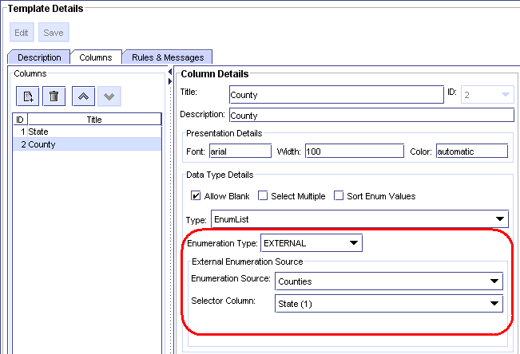
Figure 7-48: County Column Using Enumeration Source and Selector Column

LDAP, Authentication, and Authorization

Overview and Definitions
PowerEditor provides the capability to store and retrieve user authentication and authorization information, either internally, externally, or both. For those not savvy with the lingo:
Authentication: Verify that the username/password is an authentic login for the PowerEditor
Authorization: Verify what actions authenticated user is authorized to perform.
LDAP: Light-weight Directory Access Protocol – This protocol is used for accessing hierarchical views of various objects, and is commonly used for retrieving and storing authentication/authorization information.
Privileges: A list of various actions that users might be authorized to perform. PowerEditor privileges include actions like View Entity Data, Edit Entity Data, Manage Guidelines, Export Data, and Deploy. Privileges are mostly hard-coded in the PowerEditor, since they are very application specific.
Roles: An aggregation of privileges that define a set of actions required for a person to fulfill a business role. For example, a business analyst role would have privileges for Entity Data, Edit Entity Data, Manage Guidelines, while a rule administrator role would have Export Data and Deploy privileges. Roles are very site specific, and are customizable in the PowerEditor.

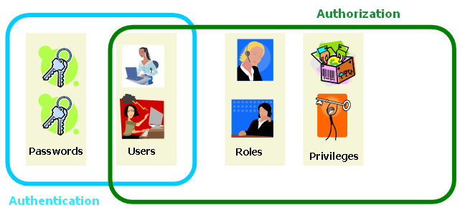
Figure 7-49 Definition of Authentication and Authorization
PowerEditor provides the ability to configure authentication and authorization for the following 3 scenarios:
- PE Authentication / PE Authorization (shortened as PE Authentication)
- LDAP Authentication / LDAP Authorization (shortened as LDAP Authentication)
- Custom Authentication / PE Authorization (shortened as Custom Authentication)

PE Authentication
Everything is stored in the PowerEditor DB: there are no external interfaces.
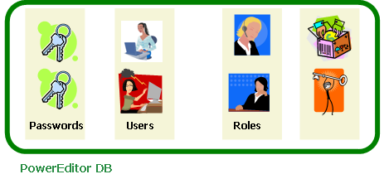
Figure 7-50 PE Authentication/Authorization

LDAP Authentication
Users, Passwords and Roles are stored externally, and accessed via an LDAP API. Privileges are stored in PowerEditor DB. In this case, roles are defined in the PowerEditor, and are referenced in the LDAP tables.
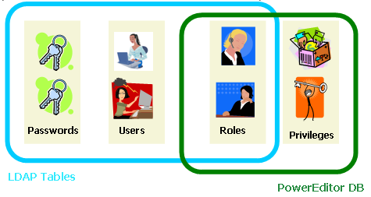
Figure 7-51 LDAP Authentication/Authorization

Custom Authentication
Everything is stored in the PowerEditor database except passwords. At login time, PowerEditor passes username and password to a custom plug-in (e.g. an EPASS plug-in), which authenticates the login. In this scenario, user names need to be stored in the PowerEditor database so that they can be mapped to PE-defined roles. However, the main authentication point for users and passwords is in the external system.

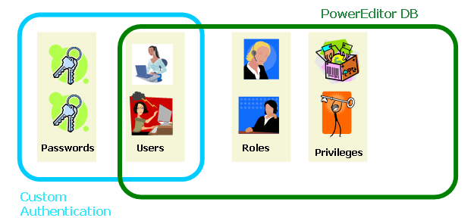
Figure 7-52 Custom Authentication / PE Authorization

PE Authentication Configuration Overview
The PowerEditor Configuration file has 3 main elements pertaining to authorization and authentication. The following is an overview of how to configure these elements for the above 3 scenarios.

PE Authentication and Authorization
To configure the PowerEditor to use PE authentication and authorization:

1. Ignore the <Server><LDAP> element (it doesn’t matter if this is commented out or not)
2. Comment out the <Server><Database><UserManagementProviderClass> element, disabling LDAP authorization
3. Comment out the <UserAuthenticationClass> element, disabling any external authentication

LDAP Authentication and Authorization
To configure the PowerEditor to use LDAP Authentication and Authorization:

1. Configure the <Server><LDAP> elements, as described below in the section titled PowerEditor LDAP Configuration Options.

2. Uncomment the following element, thus enabling LDAP authorization
<Server>
<Database>
<UserManagementProviderClass>com.mindbox.pe.server.db.LDAPUserManagementProvider
</UserManagementProviderClass>

3. Uncomment the following element, the enabling LDAP authentication
<Server>
<Session>
<UserAuthenticationClass>com.mindbox.pe.server.spi.db.DefaultUserAuthenticationProvider
</UserAuthenticationClass>

Custom Authentication / PE Authorization
To configure the PowerEditor to use Custom Authentication and PE Authorization:

1. Ignore the <Server><LDAP> elements (it doesn’t matter if they are commented out)

2. Comment out the <Server><Database><UserManagementProviderClass> element, thus disabling LDAP authorization.

3. Uncomment and edit the following element, thus enabling a custom authentication. In this element, specify the name of the class that provides an interface to the custom authentication server. Use the fully qualified classname for the custom class, and put the class file in the server classpath.
<Server>
<Session>
<UserAuthenticationClass>com.xyz.powereditor.security.CustomAuthenticator
</UserAuthenticationClass>

LDAP Overview
Now that we have a good understanding of authentication and authorization, let’s talk specifically about LDAP. This is a brief overview of LDAP as it pertains to the PowerEditor.

LDAP (Light weight Directory Access Protocol) is an API for communicating with directory server applications, LDAP servers, which provide hierarchical view of various objects. Unlike DBMS, LDAP servers maintain a hierarchy of objects. Each object in LDAP servers has attributes, which are analogous to columns of a DB table. But, LDAP object attributes differ from DB table columns in that (1) unused attributes do not take up any physical disk space and (2) attributes may contain more than one value.

To use LDAP for authentication or authorization, the PowerEditor will need be able to access a preinstalled LDAP server. The LDAP server must support LDAP v3. Most customers that require LDAP will already have an LDAP server preinstalled. However, for testing, you might want to install an LDAP server and client on your machine. Appendix I: LDAP Server Sample Installation contains instructions for installing OpenLDAP, and a very lightweight LDAP client called JXplorer. These applications are not intended for production purposes.

An LDAP server has user objects and container objects (meaning that they can have other objects in them). User objects typically have user id and password attributes, and are typically contained within a container object. Each LDAP object has an attribute called objectclass which identifies what kind of object it is. User objects will typically have inetOrgPerson or user as a value of their objectclass attribute. In most cases, you will leverage these existing user nodes. However, for some degenerate cases, PowerEditor provides a custom user objectclass called powerEditorOrgPerson.

PowerEditor LDAP Configuration Options
To configure LDAP for authentication and authorization, you most perform the three steps itemized in the above as outlined in the LDAP Authentication and Authorization section.

<LDAP>
<Connection>ldap://localhost:389</Connection>
<AuthenticationScheme>simple</AuthenticationScheme>
<Principal>cn=Manager, dc=mindbox, dc=com</Principal>
<Credentials>hkQ0vmOMSYI=</Credentials>
<UserDirectoryDN>ou=Users, o=PowerEditor, dc=mindbox, dc=com</UserDirectoryDN>
<UserObjectClassHierarchy>top,person,organizationalPerson,powerEditorOrgPerson
</UserObjectClassHierarchy>
<UserObjectRequiredAttribute name="sn" value="name"/>
<UserIDAttribute>cn</UserIDAttribute>
<UserPasswordAttribute>userPassword</UserPasswordAttribute>
<UserNameAttribute>cn</UserNameAttribute>
<UserStatusAttribute>peUserStatus</UserStatusAttribute>
<UserRolesAttribute>peRoleName</UserRolesAttribute>
<UserPasswordChangeRequiredAttribute>pePasswordChangeRequired</UserPasswordChangeRequiredAttribute>
<UserPasswordChangeDateAttribute>pePasswordChangeDate</UserPasswordChangeDateAttribute>
<UserFailedLoginCounterAttribute>peFailedLoginCounter</UserFailedLoginCounterAttribute>
</LDAP>

The table below describes each of these elements:

LDAP Tags | Description | Req in Access Only Mode?
Connection | The LDAP connection string specifies the location of LDAP server.  This can be a Distinguished Name (DN). Examples: ldap://localhost:389 or ldap://mbhqpdc.mindbox.com:389 | Yes
AuthenticationScheme | Authentication method for connecting to the LDAP server. Valid values are anonymous and simple. To connect anonymously (w/o userid and pwd) use anonymous. Otherwise, use simple. Note that the following options are not supported: DIGEST-MD5, MD5, CRAM-MD5, GSSAPI, EXTERNAL | Yes
Principal | Principal user id for connecting to the LDAP server. | Required only if AuthenticationScheme is not set to anonymous.
Credentials | Credentials (password) used for connecting to the LDAP server. This must be an encrypted password. If this password is not used, but is not commented out, it still must be encrypted. | Required only if AuthenticationScheme is not set to anonymous.
UserDirectoryDN | Specify the Distinguished Name (DN) of directory that contains user objects. If you need to specify more than one DN, simply add more UserDirectoryDN elements.  If no UserDirectoryDN is specified, PE will use the initial directory. In this case, Connection string should have DN in it. | No
UserObjectClass | Name of user object’s objectclass attribute. This is optional. It defaults to person (inetOrgPerson) | No
AllowUpdate | deprecated in PE 5.2 – updates no longer supported
AlllowChangePassword | deprecated in PE 5.2 – updates no longer supported
AllowHardDelete | deprecated in PE 5.2 – updates no longer supported
UserObjectClassHierarchy | deprecated in PE 5.2 – only used for updates which are no longer supported
UserObjectRequiredAttribute | deprecated in PE 5.2 – only used for updates which are no longer supported
UserIDAttribute | Specifies name of LDAP user ID attribute that gets mapped to PE user ID property. Typical values include cn and uid (Using these values is recommended) | Yes
UserPasswordAttribute | Specifies name of LDAP password attribute that gets mapped to PE password property. Defaults to userPassword. Note: Do not be misled into thinking this a password that needs to be encrypted: this is the name of the password attribute. | No
UserNameAttribute | Specifies name of LDAP user name attribute that gets mapped to PE user name property. If UserNameAttribute is not specified, it is set to the cn of the LDAP user object – in which case the user's name cannot be changed in PE GUI.
UserStatusAttribute | Specifies name of LDAP user status attribute that gets mapped to PE user status property. If not specified, all user status will be set to Active, and user’s status cannot be changed in the PE GUI. Otherwise, PE will only treat the user as Active of LDAP table entry is Active. | No
UserRolesAttribute | Attribute of user objects that holds roles of a user. This must refer to a multi-value attribute. If not specified, user roles will be maintained in PE database, and you will be able to modify roles using PowerEditor | No
Figure 7-53 LDAP Configuration Elements

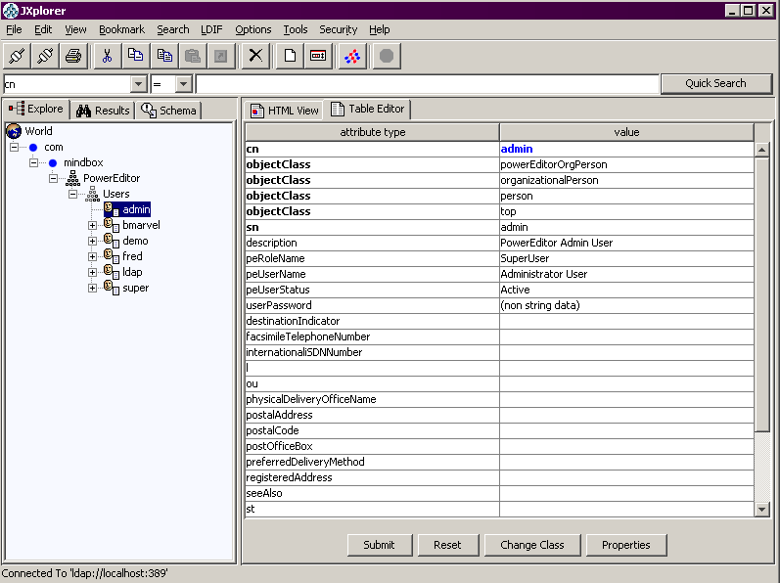
Figure 7-54 Sample Client View of LDAP User Class

Password Policies

Overview
PowerEditor can be configured to enforce site specific password policies such as minimum length, minimum number of special characters, and expiration periods. This section describes these features.

PowerEditor supports the following password policy enforcement:
- String Validation
  - minimum password length (e.g. must be at least 7 characters)
  - minimum pattern matches (e.g. 1 numeric and 1 upper case). These pattern matches are specified via regular expressions.
- Password Expiration
  - the number of days it takes for a password to expire
  - the number days prior to expiration that the user will receive notification
- Lockout after repeated login failures
  - The number of failed attempts it takes for a user to be automatically locked out
- Password History
  - The user is prevented from reusing a number of historical passwords

Note that it does not make sense to use the PowerEditor password policies if authentication is performed by an external application (e.g. LDAP). If both password policies and external authentication are enabled, password polices are ignored.

Example Password Policies
Let's say that you would like to enforce the following password policies:
Passwords must be a minimum of six characters, must not equal the previous three past passwords, and must contain at least three of the following four criteria: One upper case alpha character, one lower case alpha character, one numeric character, one non-alphanumeric character.

Here is a configuration file excerpt that implements the above password policies:
<UserPasswordPolicies>
<Validator providerClassName="com.mindbox.pe.server.spi.pwd.RegexpPasswordValidator">
<Param name="minLength" value="6"/>
<Param name="minRegexpMatch" value="3"/>
<Param name="regexp" value=".*([\p{Upper}]).*"/>
<Param name="regexp" value=".*([\p{Lower}]).*"/>
<Param name="regexp" value=".*([\p{Digit}]).*"/>
<Param name="regexp" value=".*([\p{Punct}]).*"/>
<Param name="description" value="Passwords must be a minimum of six characters, must not equal the previous three past passwords, and must contain at least three of the following four criteria: One upper case alpha character, one lower case alpha character, one numeric character, one non-alphanumeric character"/>
</Validator>
<Expiration expirationDays="90" notificationDays="14"/>
<Lockout maxAttempts="3"/>
<History lookback="3"/>
</UserPasswordPolicies>

Lockout Behavior
The following describes how users can be locked out, and how they can become unlocked. In this discussion, a system administrator is defined as someone who has the "Manage User" privilege enabled.

A PowerEditor user can be locked out for one of 3 reasons:
- Admin user manually changed the user's status to "Locked out"
- User exceeded failed login attempts threshold
- User failed to change his password before it expired.
Once a user has been locked out, when the attempt to login they will receive the same message independent of the reason for lockout.
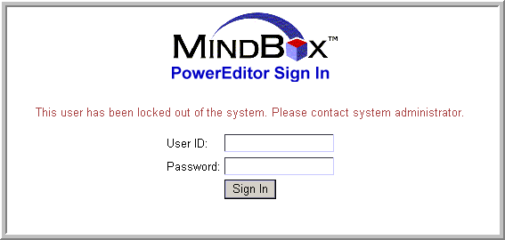
Figure 7-55 - User Locked Out!

Once a use has been locked out, an administrator must intervene by either changing the user's status to "Active" for case 1 above, or by resetting the user's password for cases 2 and 3.

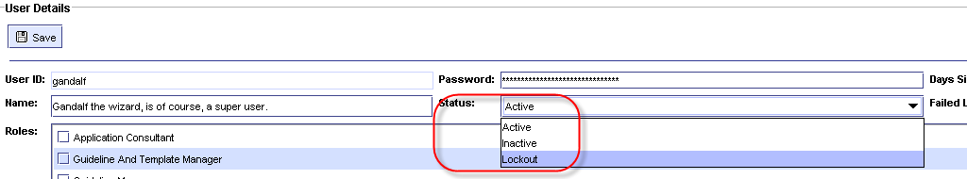
Figure 7-56 – Change Status to Active if Manually Locked Out

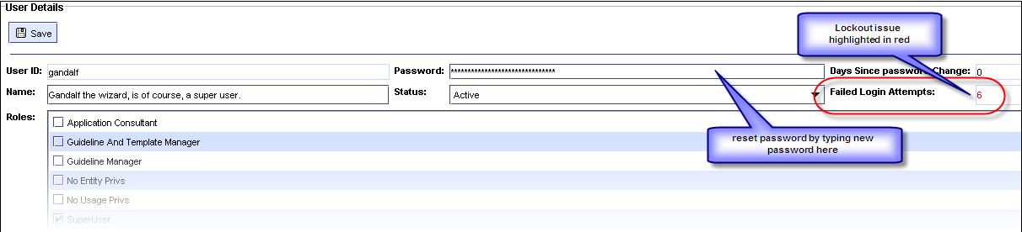
Figure 7-57 – Reset User Password if Expired or Exceed MaxAttempts

Password Policy Configuration File Specifications
The following details password policy configuration options. Note that if no password validation configuration options are specified, then passwords never expire, can be set to any non-empty string. Also, the user is never locked out except by manual intervention by the system administrator.

UserPasswordPolicy Tags | Description
Validator | This section contains the specification for valid password strings. If this section is absent, there are no restrictions on the password string.
Validator::providerClassName | This is a Java plugin for the code that handles password validation. The below validator parameters are used by the default validation plug-in, RegexpPasswordValidator
Validator::Param[name] | must be one of minLength, minRegexpMatch, regexp, or description
Validator::Param[name=minLength] | The minimum length of the password. value= is required, and must be an integer that specifies the minimum length. If the validator sees no minLength parameter, then no minimum length is enforced.
Validator::Param[name=minRegexpMatch] | The number of times that the password must match the specified regular expressions. value= is required and must be an integer which specifies the number of regular expressions that match. If single regexp matches twice, it only counts once toward the minRegexpMatch. If the minRegexpMatch parameter is missing, or the value is 0, all regular expressions are ignored.
Validator::Param[name=regexp] | A regular expression that specifies a pattern that must appear in the password. value= is required and must be a string specifying a Java regular expression.
Validator::Param[name=description] | If the user enters a new password, and the password fails to match the validator criteria, this string is displayed to the user. This string should be a textual description of all the criteria, including History and Validator parameters. Note that expiration and lockout parameters do not need to be included here, since the PowerEditor displays a different string. value= is required and must be a string.
Expiration | This section contains rules for when passwords expire. If this section is absent, passwords never expire. If a password expires before the user changes it, the user account becomes locked, and requires a system administrator to unlock. The user will simply receive a message saying that their account is locked.
Expiration[expirationDays] | The number of days it takes for a password to expire. This is measured from the date the user is created, or from the last time the password was reset.
Expiration[notificationDays] | The number of days prior to expiration that the user receives notification that their password is about to expire. This notification occurs on login.
Lockout | This section specifies the number of failed attempts it takes for a user to be automatically locked out. Once locked, a system administrator needs to unlock the account.
Lockout[maxAttempts] | Specifies the number of attempts prior to lockout.
History | This section is used to restrict valid passwords based on a user's historical passwords.
History[lookback] | The number of historical passwords that are considered invalid. For example, if this is 2, then the user's previous 2 passwords would be considered invalid. If the user attempts to set their password to either of the two passwords, they would receive the message specified in Validator::Param[description]. It is important to note that PE messaging does not differ if a password is invalid due to history, length, regexp, etc. The description message needs to cover all these cases.
Figure 7-58 Password Policy Configuration Elements

Configuration File Reference
This section contains a quick, at a glance reference for the configuration elements. Each of these are described in more detail in Chapter 6 PowerEditor Web Services API. Starting version 5.7.0, PowerEditor provides a XML Schema file named 'PowerEditorConfiguration.xsd' in the PowerEditor distribution file.

In the tables below, the Tags column contains specification for XML tags in the following format:
element-name[attribute-name]
element-name::element-name
element-name::element-name[attribute-name]

For example, in the EntityConfig table, there is the following entry:
EntityType::EntityProperty[displayName]

This specifies the following in XML:
<EntityConfig>
<EntityType name="product" ..../>
<EntityProperty name="code" displayName="Product Code" .../>

Summary of Feature Configuration Parameters
Feature configuration parameters specify which high level tabs are to be turned on and off. High level tabs that can be configured include the CBR, Phases, and Parameters tabs. See Section 7.1 High-Level Tab Configuration for a more information about these configuration options.

The following are tags which appear under the FeatureConfig element. Note that if a feature is not present in the config file, the feature will be enabled by default.
FeatureConfig Tags | Description | Valid Values | Default Value
Feature | Enable or disable a specific PowerEditor Tab
Feature[name] | Feature to enable or disable | One of cbr, parameter, or phase | no default
Feature[enable] | A boolean that specifies if the given tab is enabled | true, false | no default
Feature[className] | Name of class that holds the tab | see values in diagram below

<FeatureConfig>
<Feature name="cbr" enable="false" className="com.mindbox.pe.client.applet.cbr.CBRPanel"/>
<Feature name="parameter" enable="true"
className="com.mindbox.pe.client.applet.parameters.ParameterManagerTab"/>
<Feature name="phase" enable="true"
className="com.mindbox.pe.client.applet.admin.ProcessManagementTab"/>
</FeatureConfig>

Summary of Entity Configuration Parameters
Entity Configuration Parameters configure management of entities.

The following are tags which appear under the EntityConfig element:
EntityConfig Tags | Description | Valid Values
CategoryType | Creates category types to be associated with a generic entity
CategoryType[name] | The display name of the category (e.g. Program Category) | A string
CategoryType[typeID] | A type ID to be referenced in the generic entity definition (see below) | An integer
EntityType[name] | The internal name of the entity type. This serves as an identifier for the entity type. The value of this cannot be id or name, since these are predefined attributes automatically associated with each entity type. | A symbol
EntityType[displayName] | Name displayed for the entity. | A string
EntityType[typeID] | This needs to be a unique identifier. | An integer
EntityType[useInContext] | Specifies whether this entity get displayed in the guideline context selection. | Yes, No
EntityType[useInCompatibility] | Specifies whether this entity get displayed in the compatibility matrix. | Yes, No
EntityType[canClone] | Specifies whether the clone button is enabled for this entity. Cloning an entity puts the new entity in the context of all the guidelines that have the old entity. | Yes, No
EntityType[categoryType] | The typeID associated with the categories for this entity. This must match a value in CategoryType[typeID] | An integer
EntityType[useInMessageContext] | Specifies whether this entity is displayed in the message creation context. Only one entity can have this attribute set to yes. | Yes, No
EntityType[uniqueCategoryNames] | Specifies whether duplicate node names are allowed in the category tree for this entity type | Yes, No
EntityType::EntityProperty | Each occurrence of an EntityProperty defines a new property that will be displayed in association with this generic entity.
EntityType::EntityProperty[name] | The internal name of the property | A string
EntityType::EntityProperty[displayName] | The name shown in the GUI for the property | A symbol
EntityType::EntityProperty[showInSelectionTable] | Specifies whether this property is shown in the table which summarizes all instances of this entity. This table appears in the upper section of the entity definition screen. | Yes, No
EntityType::EntityProperty[isRequired] | Specifies whether the user is required to enter a value for this. | Yes, No
EntityType::EntityProperty[isSearchable] | Specifies whether this attribute appears in the filter screen | Yes, No
EntityType::EntityProperty[type] | The type of property that is being defined. This declares both the data type and data display. | one of: enum, string, boolean, symbol, integer, long, currency, percent, float, double, date
EntityType::EntityProperty[typeEnum] | Valid only when type=enum. Also required if type=enum. Specifies a database table in which enumerated values are listed. | A symbol
EntityType::EntityProperty[attributeMap] | Valid only when type=enum and when enumType is not used. This specifies a pointer to an enumerated list that is in the domain file. For example,  attributeMap=”LDO_LOAN_FEATURES.LoanDocumentationType” | an object.attribute reference
EntityType::EntityProperty[sort] | Valid only when type=enum. Specifies whether the PE should sort the enumerated values. | Yes, No
EntityType::EntityProperty [autoUpdatedDateProperty] | Valid only when type=date. Specifies that this date will be automatically updated whenever the specified property changes. | A symbol (property name)
EntityType::EntityProperty[allowMultiple] | Valid only when type=enum. Specifies whether the property allows multiple selections. | Yes, No

Summary of UI Configuration Parameters
UserInterface Tags | Description | Valid Values
UserInterface::Entity | Entity UI specification | n/a
UserInterface::Entity[showTab] | Show or hide Entity management UI altogether | Yes, No
UserInterface::Entity::EntityTab | Entity Tab specification | n/a
UserInterface::Entity::EntityTab[type] | The Entity Type represented by this tab. | must be the internal name of an entity type as defined in  EntityConfig::EntityType[name]
UserInterface::Entity::EntityTab[showTab] | Show or hide particular entity type tab (e.g. Product) | Yes, No
UserInterface::Entity::EntityTab::EntityPropertyTab | Define a new tab to group properties within an entity. | n/a
UserInterface::Entity::EntityTab::EntityPropertyTab[title] | The name displayed in the tab that groups properties | String
UserInterface::Entity::EntityTab::EntityPropertyTab::EntityPropertyName | Specify that the property should be displayed within the enclosed EntityPropertyTab | must be the internal name of a EntityProperty, as specified in  EntityConfig::EntityType::EntityProperty[name]
UserInterface::UsageTypeList | Begins declaration of usage types
UserInterface::UsageTypeList::UsageType | Begins declaration of a single usage type
UserInterface::UsageTypeList::UsageType [name] | Internal name of usageType. This is used for reference in this file, in template definition file, and is generated in rules. | Valid AE symbol (hyphens are suggested as word separation tokens – spaces are illegal.)
UserInterface::UsageTypeList::UsageType [displayName] | used when usageType is displayed in the PowerEditor (e.g. guideline button)
UserInterface::UsageTypeList::UsageType [privilege] | If a PE user does not have the privilege specified here, the user will not be able to view/edit guidelines of this type. | Must be a privilege defined in the PE DB
UserInterface::Guideline | Guideline UI specification
UserInterface::Guideline [showTemplateID] | If this is yes, show both template IDs and template names in GUI lists. Otherwise, just show template names | Yes, No
UserInterface::Guideline [sortEnumValue] | If this is yes, enumeration values for enumList columns are sort. | Yes, No
UserInterface::Guideline [fitGridToScreen] | If set to Yes, all guideline grids will be shrunk to fit the screen. If set to No, all guidelines will be displayed, with a horizontal scroll bar, as specified in the template. | Yes, No
UserInterface::Guideline::GuidelineTab | Guideline tab specification
UserInterface::GuidelineTab [displayName] | Shown in the GUI
UserInterface::Guideline::GuidelineTab::UsageType | Usage type specification
UserInterface::Guideline::GuidelineTab::UsageType[name] | Name of usage type. Must match with a usage type of templates in Template Definition XML | Any text
UserInterface::Policies:: EnforceSequentialActivationDates | Provides the option to enforce that all activation dates for a template and context are contiguous are non-overlapping. This applies to parameters and guidelines. Defaults to no. | Yes, No
UserInterface::DateSynonym::DefaultTime | When a date synonym is created, this is the default time that will be displayed. Typically, this the time at which the customer considers to be the start of a new day, in terms of their rules. | HH:MM
UserInterface::DeployExpirationDate::DefaultTime | Rules expired over DefaultDays ago will not be deployed, unless this value is changed in the UI. | Integer (in days)
UserInterface ::ClientWindowTitle | Sets the title of the client window | String

Summary of Rule Generation Parameters
The following are tags which appear under RuleGeneration::RuleGenerationDefault or RuleGeneration::RuleGenerationOverride
RuleGeneration Tags | Description | Valid Values | Default Value | Overrideable
RuleGenerationOverride[usageType] | Change the rule configuration based on usage type. | Valid usageType[name] |  | Yes
RuleNamePrefix::Guideline | Prefix of names of ARTScript rules generated from guidelines | Valid AE symbol | GuidelineRule | Yes
LHS::Date | Format of date in generated rules | julian, gregorian | julian | No
LHS::Pattern | ARTScript pattern specification |  | no default | Yes
LHS::Pattern[type] | Type of pattern | request, control,  plan-evaluation, lineage, empty, ruleset | Required | Yes
LHS::Pattern[generate] | Turns pattern generation on or off | Yes, No | No | Yes
LHS::Pattern[class] | Name of class for the pattern | Valid AE class name | required | Yes
LHS::Pattern[prefix] | Prefix to which class name is appended | Valid AE symbol | none – no prefix prepended | Yes
LHS::Pattern[text] | Only for type “lineage”. Static pattern text to insert in every qualified pattern | Valid ARTScript pattern | none – no pattern inserted | Yes
LHS::Pattern[variable] | Variable name referring to lineage ID. Only for type “lineage”. | Valid AE variable name | ? | Yes
LHS::Pattern  [usageTypeAsFocus] | Yes=generate usageType as focus-of-attention (MMS compatible); No=generate GuidelineTab as focus-of-attention (pre MMS).  Used only for Pattern[type=request] | Yes, No | No (pre-MMS) | Yes
LHS::Pattern::Attribute | Used only for Pattern[type=control]. These items specify how the control pattern will be generated. See Section 7.4.1.2 LHS Control Pattern for full details.
LHS::Pattern::Attribute[type] | The entity type that this attribute pertains to. | Must match the name of an entity as specified in EntityType[name]
LHS::Pattern::Attribute[name] | The internal name of this attribute. | Must match the name of an attribute in the domain object.
LHS::Pattern::Attribute[value] | Retired in PE 5.3 – PE always uses the value of the entity's ID
LHS::Pattern::Attribute[valueAsString] | Retired in PE 4.5 – deploy type is determined by the deployType in the domain file
LHS::Pattern::Value | Specifies how to deploy patterns of a certain value
LHS::Pattern::Value[type] | The type of pattern to configure. Right now there is only one configurable value: the one used for the IS-EMPTY test | one of: unspecified
LHS::Pattern::Value[deployValue] | the value that gets deployed for this pattern | symbol or string
LHS::Pattern::Value[valueAsString] | Specifies whether the deployValue will be deployed with quotes around it. | Yes, No
RHS::PEActionOn | This must be Yes. | Yes
RHS::MessageFormatConversionFunction | function called on RHS for message formatting | symbol | sprintf | Yes
RHS::MessageDateFormat | Format pattern for RHS ":message" date values. This is used when a date value is known at Rules Generation time (e.g. Guideline template grid values). | Syntax is the same as for java.text.SimpleDateFormat
RHS::MessageDateRangeFormat | Format patterns for RHS ":message" date range values. This is used when a date range value is known at Rules Generation time (e.g. Guideline template grid values). | Syntax is the same as for java.text.SimpleDateFormat
RHS::MessageDateFormatAE | Format pattern for RHS ":message" date values-used when a date value is not known until the rule is evaluated by the engine (e.g. Attribute values). | Syntax is the same as for the format-julian-date ArtEnterprise function
RHS::MultiEnumAsSequence | Specifies how multi-enum cell values are deployed in RHS. Yes=sequence, No= comma separated string | Yes, no | Yes | Yes
MessageTypes | Specifies message generation defaults |  | no default | Yes
MessageTypes::Message | Specifies how a message should be generated for a cell |  | no default | Yes
MessageTypes::Message  [type] | The cell type this specification applies to. | range, enum, conditional | required | Yes
MessageTypes::Message[rangeStyle] | The style to use to format ranges. Applies to Message::[type=range] | verbose: “greater than”, etc;  symbolic: >, >=, etc.;  bracketed: “[0, 100)” | verbose | Yes
MessageTypes::Message[cellSelection] | For specifying text and behavior that depends on specific cell selections. Applies to Message[type=enum] | enumExcludeSingle: Single enum value selected, "Exclude Selection" selected;  enumIncludeSingle: Single enum value selected, "Exclude Selection" not selected;  enumExcludeMultiple: Multiple enum values selected, "Exclude Selection" selected;  enumExcludeMultiple: Multiple enum values selected, "Exclude Selection" not selected | required for Message::[type=enum] | Yes
MessageTypes::Message[enumDelimiter] | For specifying text to be used between multiple selected items;  Applies to Message[type=enum] | Any string – eg. ", " |  | Yes
MessageTypes::Message[enumFinalDelimiter] | For specifying text to be used between the next-to-last and last multiple selected items;  Applies to Message[type=enum] | Any string – eg. ", or " |  | Yes
MessageTypes::Message[enumPrefix] | Test that will be prepended to the cell value;  Applies to Message[type=enum] | Any string – eg. "Any of " |  | Yes
MessageTypes::Message[conditionalDelimiter] | For specifying text to be used between conditionally generated column text; Applies to Message[type=conditional] | Any string – eg. ", " |  | Yes
MessageTypes::Message[finalConditionalDelimiter] | For specifying text to be used between the next-to-last and last conditionally generated column text; Applies to Message[type=conditional] | Any string – eg. ", and " |  | Yes
ObjectGenerationDefault | Specifies options for parameter generation |  |  | No
ObjectGenerationDefault:: InstanceCreateText | AE function for creating parameter instances | One of: make-instance, create-instance |  | No
ObjectGenerationDefault:: ParameterContext | Used to specify the mapping between context elements and domain elements |  |  | No
ObjectGenerationDefault:: ParameterContext::Attribute | Specifies a particular parameter context element. |  |  | No
ObjectGenerationDefault:: ParameterContext::Attribute[type] | Specifies a handle to particular parameter context element. | the name of an entityType, or one of activationDate, expirationDate |  | No
ObjectGenerationDefault:: ParameterContext::Attribute[name] | Specifies the domain attribute to which this context element maps. | The name of a domain attribute that will be present in the AE parameter object. |  | No
ObjectGenerationDefault:: ParameterContext::Attribute[value] | Specifies which entity property will be used when deploying a parameter that uses an entity instance. | Must be a valid EntityProperty[name] for the given entity type. |  | No
ObjectGenerationDefault:: ParameterContext::Attribute[valueAsString] | Specifies whether the attribute will have quotes around it when deployed | Yes, No |  | No

Summary of Server Parameters
Server Tags | Description | Valid Values | Default Value
KnowledgeBase::DomainFile | Location domain definition file | Valid filename
KnowledgeBase::TemplateFile | Location parameter template definition file | Valid filename
Audit::AuditAll | Turns audit trail on or off | Yes, No
Database::Provider |  | com.mindbox.pe.server.db.DefaultPEDBCProvider
Database::MaxConnection | Maximum number of concurrent DB connections allowed | Positive integer. Value >= 10 recommended
Database::MonitorInterval | ??
Database::UserManagementProviderClass | Only use this element if you want to use LDAP for user authentication and authorization | com.mindbox.pe.server.db.LDAPUserManagementProvider
Database::Driver | Fully qualified name of the DB Driver class. | Fully qualified class name
Database::Connection | Database connection string. | Valid DB connection string
Database::User | Login name for accessing the DB. | Any string
Database::Password | Password for the DB user. | This must be a string that is encrypted as an output from the PowerEditor Password tool.
Database::ValidationQuery | Query execute to validate each DB connection before using it, if specified. This is an optional entry. Example: select count(*) from MB_PRIVILEGE | This must be a valid query select query.
EnumerationSources | For the Enumeration source entries, see Figure 7-47 Enumeration Source Configuration Elements.
LDAP | For the LDAP entries, see Figure 7-53 LDAP Configuration Elements.
UserPasswordPolicies | For password restrictions. See Figure 7-58 Password Policy Configuration Elements.
Deployment::BaseDir | Directory where generated ARTScript files are stored | Valid directory name
Deployment::SaveOldFiles | If Yes, Instructs PE to save previously generated ARTScript files | Yes, No
Deployment:: UseTimeStampFolder | If Yes, PE places generated ARTScript files to a time-stamp directory. | Yes, No
Deployment::ReportMissingLink | If Yes, report missing links at deployment. Use Yes here, unless you had linkage problems when upgrading from PE 3.3.0. | Yes, No | Yes
Deployment::PostDeployScript:File | Contains the name of an optional deploy script file. This file will be executed after rules are deployed | Valid filename | no default (no script is run)
Log::LogFile | XML Tag per each log file. |  | no default
Log::LogFile[type] | Log file type. | database, deployer, loader, server, servlet | Required
Log::LogFile[writeLog] | Indicate whether to write the log of the specified type. | Yes, No | No
Log::LogFile[debug] | Indicate whether to write debug messages. | Yes, No | No
Log::LogFile[file] | Full path to the log file. Make sure the directory of the file exists, or the log file won’t be written. This attribute is ignored for log type of “servlet” as Servlet log entries are written to “server” log. | Valid filename | Required
Log::LogFile[pattern] | Format of each log line. Must conform to Log4J format. | Valid Log4J Log entry format. | %d{yyyy-MM-dd HH:mm:sss} %c{2}: %m%n
Log::LogFile[maxSize] | Max size of logfile in MBytes. When file exceeds size, a new logfile will be created. | Positive Integer | No size limit
Session:: MaxUserSessions | Number of distinct session allowed for the same user ID | Positive integer. | 3
UserAuthenticationProviderClass | For external hashing of user passwords | Could be a custom class. If you want to use the LDAP interface for password verification, use com.mindbox.pe.server.spi.db.DefaultUserAuthenticationProvider

Appendix I: LDAP Server - Sample Installation
This appendix contains instructions for installing a sample LDAP server and client for testing purposes. The applications are not intended for production purposes. The sample LDAP server documented here is OpenLDAP. The sample LDAP client documented here is a very lightweight LDAP client called JXplorer.
The server application (OpenLDAP) is what contains the user and password information. The client application is an interface that allows you to edit the information stored in the server.

Obtain Configuration Files
Obtain the following files from Mindbox Technical Support:
- slapd.conf
- powereditor.schema
- mindbox-dc.ldif
- powereditor-user.ldif

Install and Configure LDAP Server Application (OpenLDAP)

- For Windows OpenLDAP installer, download it from http://download.bergmans.us/openldap/openldap-2.2.29/. More recent versions might have made available since this document was written. You might find the following link to be useful: http://lucas.bergmans.us/hacks/openldap/download. For non-Windows installation, visit http://www.openldap.org. For any OS, you need to find a slapd, not slurpd implementation for your OS.

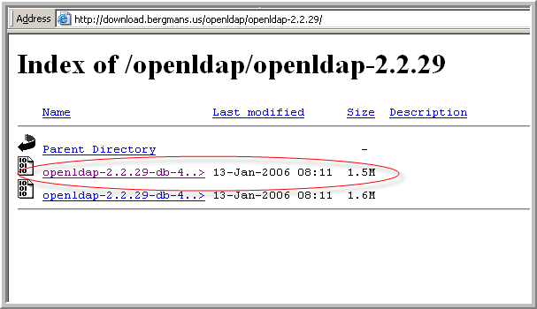
Figure 9-59 OpenLDAP Download Site
- Run the OpenLDAP installer. Make sure to select slapd, not slurpd.
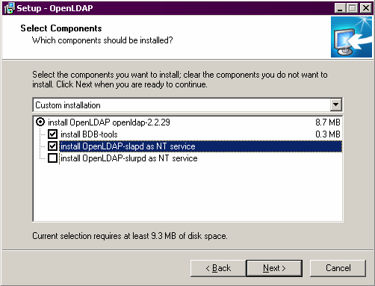
Figure 9-60 Installing OpenLDAP
- Configure OpenLDAP with PowerEditor specific files.
  - Place file slapd.conf into your <openLDAP> installation directory, overwriting the existing file.
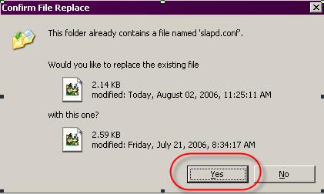
Figure 9-61 Just Say Yes

  - Place file powereditor.schema into <openLDAP>/schema directory.

- Start OpenLDAP. It should be ready for connection.
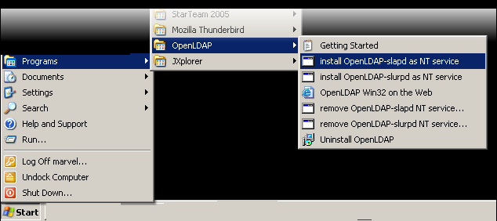
Figure 9-62 Starting OpenLDAP from Windows
- At that point, you probably want to verify that OpenLDAP is running. Here is some background: Port 389 is typically used by LDAP servers. OpenLDAP is by default configured to listen to Port 389. To verify that this port is being used (hopefully by OpenLDAP) do the following.
  - open a DOS window
  - type netstat –na
  - verify that something is listening to port 389

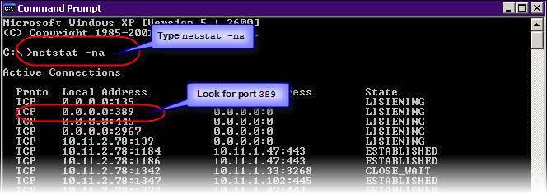
Figure 9-63 Verify that the LDAP server is running

Install LDAP Client Application (JXplorer)
- Install LDAP Client application. You can use JXplorer LDAP Browser, available at http://www.jxplorer.org/ or Argonne’s LDAP Browser, available at
http://www.novell.com/coolsolutions/tools/13765.html.
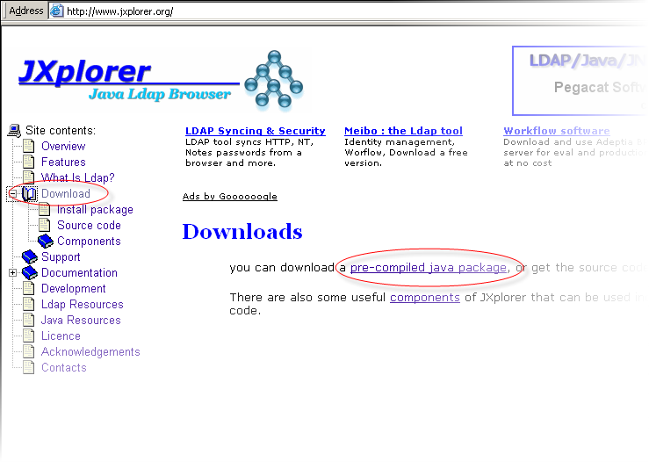
Figure 9-64 Downloading JXplorer

- Use your LDAP client application (e.g. JXplorer) to import the file mindbox-dc.ldif. Close your LDAP client application and OpenLDAP.

Use Client Application to Configure PowerEditor LDAP Settings
- Start your LDAP client application.
- From your client, enter settings in PowerEditor Configuration. The UserDN and Password settings are based on values that are in the slapd.conf file.
  - Host: localhost
  - Port: 389 - This the default for LDAP servers.
  - Level: User+Password
  - Password: secret - This is specified in the slapd.conf file.
  - UserDN: cn=Manager, dc=mindbox, dc=com - This is specified in the slapd.conf file. Note that the PowerEditorConfig file will also contain this value in the <Principal> section.
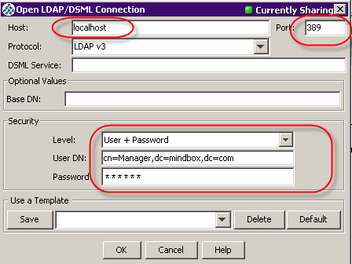
Figure 9-65 LDAP Client Application
If you get these dialogs, it’s OK.
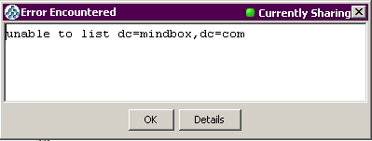
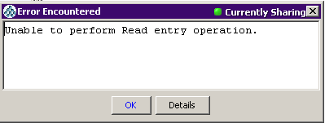

- Using your LDAP client application, import the file mindbox-dc.ldif.
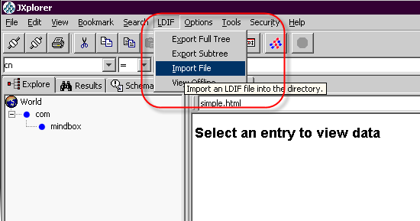
Figure 9-66 Import mindbox-dc.ldif
If you get this dialog, it's OK
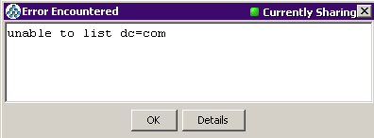

- Using your LDAP client application, import the file powereditor-user.ldif. (XXXX)
Figure 9-67 Import powereditor-user.ldif

If you see the PowerEditor directory structure, you've succeeded so far.

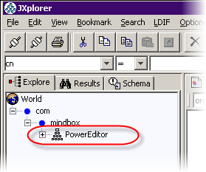
Figure 9-68 Result of Importing Two ldif Files

- Add and edit users. In JXplorer, go to the Table Editor. Use menu items to add and edit users.
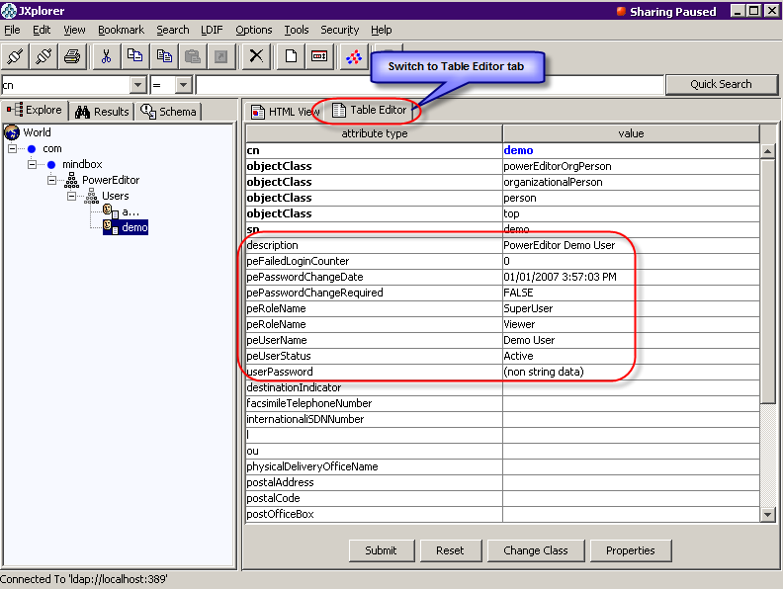
Figure 9-69 Editing LDAP User Information

If your PowerEditor is configured for LDAP, you should see the effects of these edits the next time you login to the PowerEditor.

Restarting JXplorer
When you restart JXplorer, you’ll need to re-establish your LDAP connection.
You'll need to reenter all the data you entered in the start of the previous section, including Level, User DN and Password.
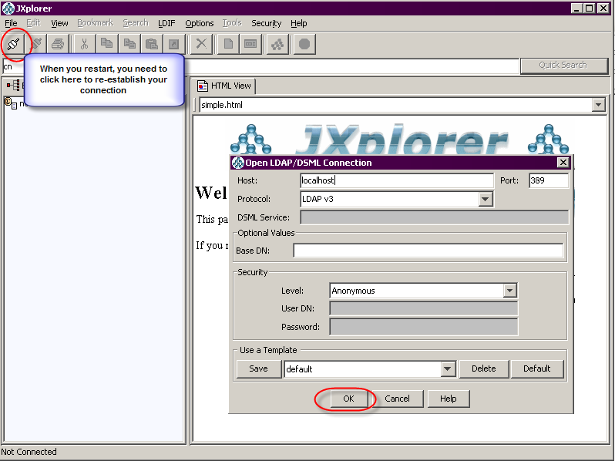
Figure 9-70 Restarting JExplorer

Debugging Open LDAP
If the OpenLDAP service doesn't start, you can try the following
- in a DOS window, cd to the OpenLDAP directory (e.g. C:\Program Files\OpenLDAP
- type slapd.exe
- if you see the DOS prompt immediately after hitting return, OpenLDAP didn't start properly
- type slapd.exe –d 5
- you should see a bunch of debugging information
- if it says that your database needs to be recovered, type db_recover –h data
- now try slapd.exe
- if the DOS prompt doesn't come back, slapd is running. You can let it continue to run, or type control-C, and go start it as a service
- in a DOS window, type nstat –na to verify that port 389 is in use.

DomainEditor is in development at the time of this writing. Consult the Development group for more information.
See section on PowerEditor Encryption Tool

